Year 1 - Animals including humans SCIENCE KNOWLEDGE ORGANISER
Key Vocabulary |  | Key Knowledge
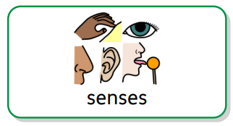 | How our bodies send messages to our brains. | 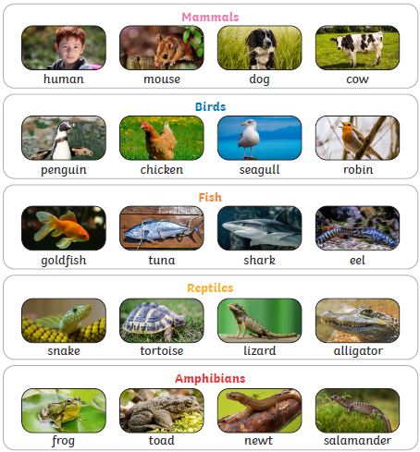  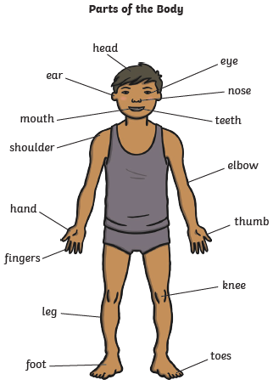
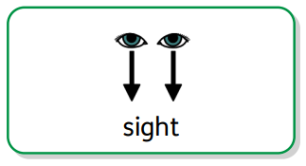 | Your eyes let you see all of the things around you.
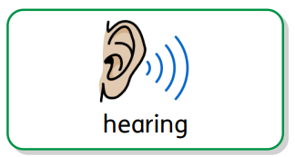 | Your ears let you hear all of the sounds around you.
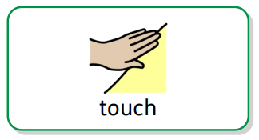 | Your skin feels if things are hot, smooth or wet.
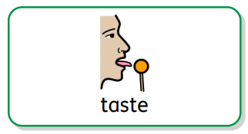 | Your tongue tells you if food tastes sweet or sour.
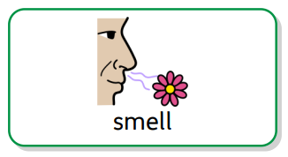 | Your nose can tell if things smell nice or not.
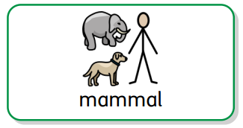 | Mammals grow fur or hair and they give their babies milk.
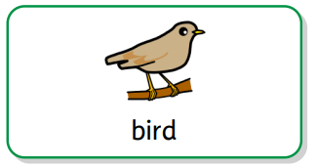 | Birds have beaks, two legs, feathers and wings.
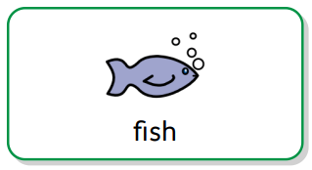 | Fish breathe underwater and they have scales and fins.
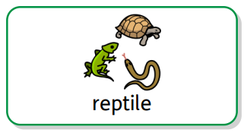 | Reptiles breathe air and they have dry, scaly skin.
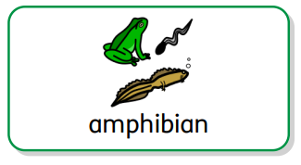 | As babies, amphibians live in water, then on land as they grow up. They have slimy, smooth skin.
Key Questions
What are the five senses of your body? |  | Sight, hearing, touch, taste and smell.
What is a carnivore? |  | An animal that only eats other animals – it is a meat eater e.g. lions, wolves, snakes, eagles and sharks are carnivores.
What is a herbivore? |  | An animal that only eats plants e.g. cows, sheep, horses, rabbits and elephants are herbivores.
What is an omnivore? |  | An animal that eats both plants and other animals e.g pigs, bears, hedgehogs, squirrels and humans are omnivores.

