Dreams and Goals possible obstacles
Remember the book Me……Jane. Think what her goal was. Read the stages in her life below that led to her achieving the goal.
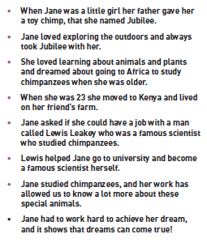

Think about the possible obstacles that may have stopped her.
She moved to Kenya when she was 23 and lived on a friend’s farm.
What could she have done if she didn’t have enough money to go there or a friend to live with?
Discuss with an adult or partner.
Could she have saved more money, maybe got a job and flat to live in out in Kenya? That would be a way to overcome her obstacles.
What if Lewis hadn’t helped her to go to University?
She would have had to work harder to get more money for University.
There is a way to overcome obstacles you just need to talk to people for advice, help and choose a way forward.

Task
Think of 3 obstacles that might stop you achieving 3 of the goals you chose in previous weeks. Write the obstacle and then in the star write a way to overcome this. Discuss each solution with a partner or adult.

1.

2.

3.

