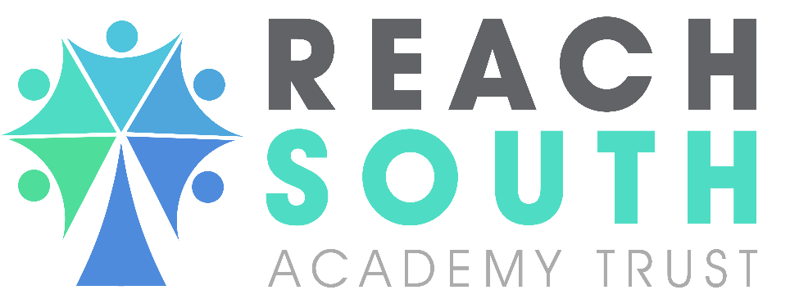

Low Level Concerns Policy
Drake and Morice Town Primary Academies
CONTENTS

Section | Description | Page No.
1.0 | Rationale | 3
2.0 | Considerations | 3
3.0 | Procedures | 3

1. | Rationale
1.1  1.2  1.3 | Research from serious case reviews has shown that early identification of any inappropriate behaviors, conduct and attitudes displayed by adults and prompt and appropriate management of such concerns, is fundamental to an effective safeguarding practice. A transparent culture where concerns can be identified and openly discussed, means that adults can raise and share concerns about such behaviours and attitudes displayed by staff or by themselves. This helps to promote an effective and robust safeguarding system.  Creating a positive culture is paramount, which allows staff to raise concerns about other members of staff, particularly where the threshold for an allegation is not met. Any concerns can then be shared responsibly with the appropriate person, recorded and dealt with as required in order to help protect children from possible harm and abuse. By implementing such a policy, we encourage an open and transparent culture, enabling staff to identify any concerning, problematic or inappropriate behaviours. This minimises the risk of possible abuse, and ensures that staff working with children are clear about the professional boundaries expected of them.  Drake and Morice Town Primary Academies are committed to safeguarding and promoting the welfare of pupils and expects all staff and volunteers to share this commitment. It is our aim that all children fulfil their potential. This policy, applies to the whole school including the Early Years Foundation Stage (EYFS).
2 |  | Considerations
2.1  2.2  2.3 |  | There will be times when staff, as professionals, have to act in a particular way in order to protect the health, safety and welfare of children. Such situations could put the member of staff in a potentially vulnerable position. Staff may later reflect following an incident, and identify how they could have acted differently.  There may be occasions when an incident occurs which is out of the ordinary, and which causes a member of staff to have doubts about the behaviour, of another member of staff towards a child. On other occasions, a member of staff may identify concerns about their own behaviour in a specific situation, and how this may be misinterpreted by others.  It is important that such occasions and/or incidents which might give rise to such concerns are reported promptly to the Designated Safeguarding Lead (DSL). In the vast majority of cases, there will be a perfectly innocent and reasonable explanation for what has occurred. However, best practice would result in documenting incidents, concerns, discussions, and agreeing any actions.
3 |  | Procedures
3.1  3.2  3.3  3.4  3.5  3.6  3.7  3.8 |  | The procedure for self-reporting or reporting a concern of this nature is referred to as a 'Low Level Concern’.  The purpose of a low-level concerns process is to protect both children and the staff working with them. It creates a system for recording observations or situations where there are concerns where they do not meet the threshold criteria to implement the school’s allegations policy and a referral to LADO/DOFA. Records will be kept securely of any low level concerns received. The DSL will monitor the notifications and notify the Trust Safeguarding Lead if any patterns begin to emerge.  Low-level concerns are a neutral act, and the DSL will, on receipt of a low-level concern, determine how to best to proceed. If required, the DSL may consult with the Head Teacher or Trust Safeguarding Lead to agree next steps.  Low-level concerns can be made informally in the first instance. Following receipt of a concern the DSL will gather information as required depending on the concern being raised. All information received will be documented using the Low Level Concerns Form. Records will be kept confidentially and shared only with the relevant staff and agencies such as the LADO/DOFA when the threshold criteria is met.  A staff member who makes a low-level concern in good faith will suffer no detriment as a result of raising a concern. However, failure to make a low-level concern, or raising a malicious notification could constitute misconduct and lead to the implementation of the school’s disciplinary procedure.  The circumstances in which staff should make a low-level concern are as follows:  • any incident where s/he feels that his/her actions or behaviour towards a child could be misinterpreted;  • any incident which a member of staff is aware of actions of a colleague towards a child which could be misinterpreted;  • any incident of which a staff member is aware where the interactions of a colleague with a child are not appropriate to the child’s age or developmental need at that time;  • inadvertent email, messaging, use of social media sites or other communication between staff and children outside agreed protocols;  • any unsupervised contact with a child other than in the context of a one-to-one lesson or discussion about academic, extracurricular or pastoral issues or other situations which fall within expected boundaries of professional conduct;  • any incident where a member of staff has been alone with a child or transporting children in a vehicle where this has not been authorised in advance;  • any inadvertent and potentially inappropriate social contact with children outside of school (such as restaurants or pubs);  • if a child uses a staff member's home address, mobile or home phone number, or private e-mail address;  • one-to-one contact with a child on school trip [residential / non-residential] which falls outside expected boundaries of professional conduct;  This is not intended to be an exhaustive list but representative. Anything which causes staff to have a 'nagging doubt' about the way in which other adults behave or interact with children, or how their own actions could be viewed should be notified. This is in order to protect both children and the members of staff involved.  NB Where there is evidence that a professional boundary has been broken and the threshold for allegations has been met, the Neutral Notification’s process must be bypassed and the school’s procedures for managing allegations must be followed. See Safeguarding Policy/ Allegations.

POLICY HISTORY

Policy Date | Summary of change | Contact | Implementation  Date | Review Date
September 2020 | New policy implemented | Safeguarding | September 2022 | September 2022
September 2022 | Policy accepted | Safeguarding | September 2023 | September 2025

