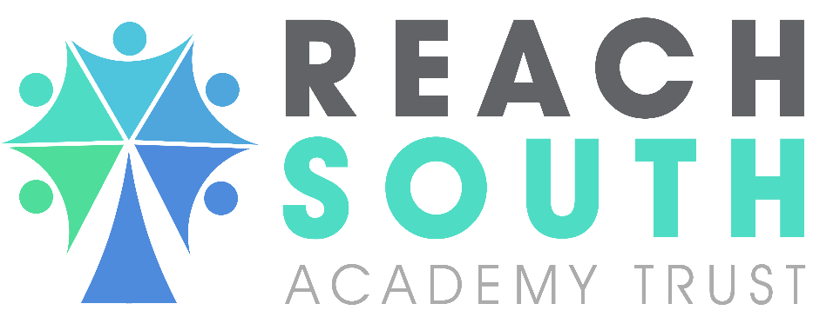

Allegations Against Staff Policy
Drake and Morice Town Primary Academies
CONTENTS

Section | Description | Page No.
1. | Allegations Against Staff | 3
2. | Contact Details | 4
3. | Steps to be Taken in the Event of an Allegation | 4
4. | Actions to Take if a Member of Staff Resigns Because of an Allegation | 6

1. | Allegations against staff
1.1  1.2  1.3  1.4  1.5  1.6  1.7  1.8  1.9 | This Policy states the actions we will take when we receive allegations or concerns about staff members, including supply staff, volunteers and contractors. Allegations may indicate that a person is unsuitable to continue to work with children in their present position, or in any capacity. It is used in respect of all cases in which it is alleged that a member of Academy staff (including volunteers, supply staff and contractors) has:  • Behaved in a way that has harmed a child, or may have harmed a child.  • Possibly committed a criminal offence against or related to a child.  • Behaved towards a child or children in a way that indicates they may pose a risk of harm to children.  Behaved or may have behaved in a way that indicates that they may not be  suitable to work with children.  All staff and volunteers must be made aware of the procedures to follow in the event of an allegation or concern against a member of staff.  We will manage and respond to allegations against staff in line with local safeguarding board procedures. A copy can be found here Plymouth Children and safeguarding Partnership  www.plymouthscbdev.delthosting.co.uk/protocols-policies-and-procedures  All staff are required to have an understanding of what to do if they receive an allegation against another member of staff, or if they themselves have concerns about the behaviour or conduct of another member of staff. Staff will be provided with the information they need to be able to raise an allegation directly with the DOFA/LADO should they feel it necessary.  Any allegations that are received that relate to a member of staff who is no longer employed or are historical allegations of abuse will be reported to the Police.  In some cases, an immediate referral must be made to children’s social care or the police for investigation, if we have reason to believe that a child or children appears to have been harmed or is at risk of significant harm and/or a criminal act may have been committed.  Ofsted will be informed of any allegation made against a member of staff who works within the early year’s age group (children under 5 years) and/or any allegations regarding staff who work in any before or after school provision which is registered on the Childcare Register and/or Voluntary Childcare Register with Ofsted.  We will report any allegations to the DOFA/LADO that relate to professionals who we know, that work with children, for example, childminders, foster carers and adoptive parents.  All allegations against staff at the school should be reported straight away to the Executive Headteacher, Joe Roberts or in his/her absence the Head of Schools Susie Carroll or Head of Welfare Pauline Donnellon. If the allegation is against the Headteacher it must be reported to the Chair of Governors, Janice Carr. The Designated Officer at the Local Authority (DOFA/LADO)[insert name], Head of Safeguarding, Johanna Hughes and CEO, Dean Ashton must also be contacted in all cases.
2. |  | Contact details
DOFA / LADO (delete as appropriate):

Plymouth:LADO –Jane Parmenter
Tel: 01752 306340
Email LADO@plymouth.gov.uk.

Head of Safeguarding Reach South Academy Trust:
Johanna Hughes
Tel: 07592327824
Email: Johanna.hughes@reachsouth.org

CEO:
Dean Ashton
Tel: 01752 284257
Email: info@reachsouth.org

Chair of Governors :
Janice Carr
jcarr@drakeprimaryschool.co.uk

Ofsted :0300 123 1231
Email: enquiries@ofsted.gov.uk
3. |  | Steps to be taken in the event of an allegation
- Report allegations to the DOFA / LADO. We have a duty to report allegations and take advice on how we should respond. This should be done as soon as reasonably possible, but should not exceed one day. DOFA / LADO will advise on next steps.
- For allegations against staff that relate to children under 5, and/or for children accessing before and after-school provision, we will notify Ofsted of the allegation.
- Inform the Trust Safeguarding Lead, Johanna Hughes of any allegations received and the actions taken.
- Only inform the member of staff that an allegation has been made, if advised to do so by DOFA / LADO. We will aim to minimise any stress inherent to staff involved during the allegations process. Staff can be advised to contact their trade union representative if they have one.
- In some cases, it may be appropriate to suspend the member of staff. This may only be done with the agreement of DOFA/LADO and Director of HR Olivia Frings.
- Conduct an internal investigation if advised to do so by the DOFA / LADO and liaise and report findings to the DOFA / LADO.
- For allegations that meet criteria, the Headteacher / Deputy Headteacher or representative identified will attend a Strategy Meeting and offer assistance with any investigation or enquiries by the Police. In rare circumstances, some allegations will be so serious they will require immediate intervention by children’s social care and/or the police.
- We will gather any additional information which may have a bearing on the allegation e.g. previous known concerns, a timeline of events, care and control incidents and any other relevant documents.
- We will inform the member of staff of the allegation and ensure they receive effective support, information and a named point of contact if they are suspended. In some circumstances, it may not be deemed appropriate to share the detail of the allegation. This will be determined during your discussions with the LADO / DOFA.
- Implement an effective risk assessments if appropriate and necessary.
- Ensuring that effective reporting and recording systems are in place to allow for the tracking of all allegations with a chronology of events and actions through to the final outcome.
- Referring as appropriate to the Disclosure and Barring Service (DBS) or other bodies/professional organisations.
- If there are concerns about the person’s behaviour towards their own child/ren or child/ren unrelated to their employment or voluntary work and there has been a recommendation from a strategy discussion, we will take careful consideration about any risks posed to children they work with.
- When an allegation is made about abuse that took place some time ago and the accused person may still be working with or have contact with children.
- When an allegation relates to a supply member of staff. The DSL will liaise directly with the LADO/DOFO. The agency who has supplied the member of staff, will be fully involved and cooperate with LADO/DOFA enquiries. Supply staff will be advised to contact their trade union representative if they have one in the event of an allegation. If this is not the case, they will be advised to seek a colleague for support.

Maintain confidentiality, and guard against any unwanted publicity. Take advice from the DOFA/ LADO, police and children’s social care about what information can be shared. Discuss what information can be given to the wider community to prevent and reduce any speculation and how you will respond if the press become involved.
 |  | In the event of the Head teacher or designated Deputy Head Teacher’s unavailability or an allegation being made against the Head Teacher and or Deputy, the appointed Senior Manager) should:
- Inform DOFA / LADO of allegation. Inform Trust staff as above.
- Collate and record information you have and personal details about (i) the child/ren, parents/carers, siblings; (ii) the person against whom the allegation has been made; and (iii) details of any known or possible witnesses, including checking on and recording, with times, dates etc, any other incidents or concerns about the child/ren or the member of staff/volunteer concerned together with actions taken and outcomes. At the same time it’s important to keep alert for patterns which might suggest the abuse goes further afield and involves other children and adults;
- Inform the person reporting the allegation or concern what action you will take ( and what they are expected to do), with regard to local information sharing protocols and the need to maintain confidentiality;
- Ensure that the alleged perpetrator or person about whom there is a concern is informed of the allegation or concern as soon as possible after consulting with the DOFA / LADO. This should include how enquiries will be conducted and sources of support and advice, e.g. from professional organisations/trade union;
- Help all parties understand the process throughout.
- Keep clear written evidence of actions taken.
 |  | You must not:
- Delay referring to the DOFA / LADO in order to gather further information or for any other reason
- Take any action that might undermine any future criminal investigation or child protection enquiry, such as interviewing the alleged victim or potential witnesses as part of an internal disciplinary procedure, or informing or interviewing the alleged perpetrator, prior to contacting the DOFA / LADO, (or without the go-ahead from police or social care if a direct referral has been made). The DOFA /LADO will liaise with the police and/or social care as necessary, as they may want to place restrictions on the information that can be shared.
- Automatically suspend or dismiss the member of staff without seeking further advice.
- Inform parents/carers of the child/ren until advised to do so by the DOFA / LADO or a strategy meeting, other than in emergency, such as when a child has been injured and needs medical attention. The DOFA / LADO will advise on how and by whom parents/carers should be informed and will liaise with police or social care where they are or may need to be involved.
- Cease to use a member of supply staff due to safeguarding concerns.
4. |  | Actions to take if a member of staff resigns because of an allegation
4.1 |  | If a member of staff resigns following an allegation, or mid-way through an investigation, the Head Teacher or Deputy Head Teacher will continue with the investigation. If the criteria is met, a referral to the DBS must be made.
4.2 |  | Schools and colleges have a legal duty to refer to the DBS anyone who has harmed, or poses a risk of harm, to a child or vulnerable adult where:
- the harm test is satisfied in respect of that individual;
- the individual has received a caution or conviction for a relevant offence, or if there is reason to believe that the individual has committed a listed relevant offence
- the individual has been removed from working (paid or unpaid) in regulated activity, or would have been removed had they not left. (KCSIE 2021)
5. Review of policy
5.1 This policy is reviewed as required by the Trust in consultation with the recognised trade unions.
5.2 We will monitor the application and outcomes of this policy to ensure it is working effectively.

APPROVAL

Name of School: | Drake and Morice Town Primary Academies
Executive Headteacher: | Joe Roberts
Head of Schools: | Susie Carroll
Head of Safeguarding and Welfare | Pauline Donnellon
Signature of Headteacher: | 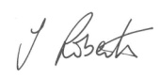
DOFA/LADO: | Jane Parmenter

POLICY HISTORY

Policy Date | Summary of change | Contact | Implementation  Date | Review Date
September 2020 | Trade Union consultation | All Recognised Trade Unions | N/A | N/A
September 2020 | New policy implemented | Safeguarding | September 2021 | September 2022

