Morice Town Primary Academy
Foundation Class
Information Booklet
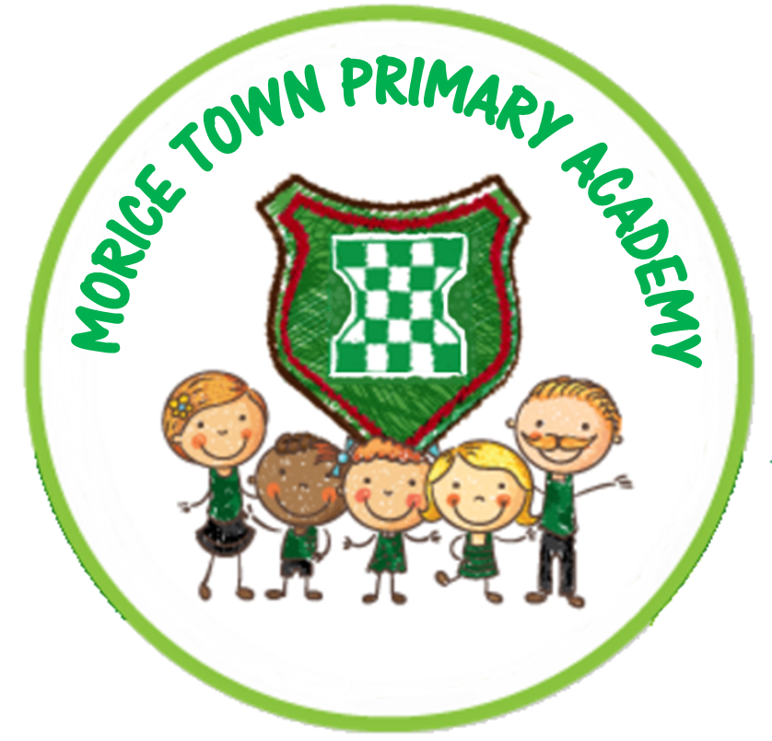

MORICE TOWN PRIMARY ACADEMY
CHARLOTTE STREET
DEVONPORT
PLYMOUTH
PL2 1RJ
TELEPHONE: 01752 567609
Email: spearn@moricetownprimary.co.uk

Welcome
Dear Parent / Guardian,

This book outlines the way we encourage children to behave and learn, and how we hope to develop a useful and productive partnership with you. We believe Morice Town Primary Academy is a very happy school where pupils, parents and staff work together to discover and nurture every child’s potential.

Morice Town Foundation Class

8.40am – 3.00pm

Our school operates an ‘Open Door Policy’. If you have any questions regarding your child, please feel free to come in to speak with a member of staff at a convenient time.

Teacher: Miss Everitt

We will have a TA and, on occasion, work experience placements and other adult helpers will be working in our class.
General Information
We appreciate a prompt arrival so learning can start as quickly as possible. We also appreciate a prompt collection. If someone else is picking up your child please let us know so we can safeguard efficiently. If your contact details change at any point, please let us so know so we can contact you if there are any problems.

Absences
If your child is absent due to sickness or diarrhoea, please keep them at home for 2 clear days. Please inform the school by 9.15 a.m. if your child is absent.

First Aid
Minor injuries will be treated at school. However, in the event of a head bump, your child will be given a sticker to wear on their clothing and staff will inform parents at home time. In the case of a more serious accident we will contact you immediately.

Medicine in School
If your child requires prescribed medicine to be administered during school hours, a permission form from the office must be completed.

Clothing
A price list for school uniform is included in this pack. School uniform and book bags can be purchased from the office. We ask that all your child’s property and clothing be clearly named. School uniform consists of: a green jumper, cardigan or sweatshirt (with or without the school logo). White shirt/polo shirt; and grey/black trousers or skirt/pinafore dress. There are also school fleeces available. Shoes without laces may be easier for children to put on without help. P.E. clothes consist of: black shorts and a plain white t-shirt for both indoor and outdoor P.E. in the summer. The children will also need trainers or plimsolls. P.E. kit needs to be stored at school in a named bag. Please make sure that your child’s school uniform, coat, lunchbox etc are clearly labelled with your child’s first name and surname.

Jewellery and Personal Belongings
Jewellery is not permitted in school. Studs may be worn in pierced ears. We also ask that personal toys or items are left at home. We cannot be held responsible for any lost or broken items. Our Foundation class will attempt to promote independence by not encouraging blankets, dummies or other personal items whilst in school so please refrain from bringing them in.

Dinnertime: 11:45am – 12:55pm
Please inform staff if your child has an allergy of any kind or a specific dietary need.
- Children may have a packed lunch or a school dinner. All Foundation children are entitled to free school meals.

- If your child is having a school dinner, they will be given a coloured wrist band to wear so that meal time staff can ensure that they get the correct meal.

- Each term a menu will be sent to you so that you can help your child make their lunch choice at home.

- During the Autumn Term 1 your child’s class teacher will be available to help them enjoy their lunch break until the children are familiar with the lunchtime routines.

Each morning your child will have a variety of fresh fruit and milk. This is free to children in the Foundation Class. Fresh water is available to children throughout the day but please bring in a named water bottle from home where possible.

Getting Ready for School
At home, please encourage your child to do things for himself/herself such as:
- Putting their coat on and taking it off (practice buttons and zips)
- Taking off and putting on shoes, socks, clothing (they will need to do this with ease for P.E lessons)
- Being independent in taking themselves to the toilet (please make me aware of any toileting issues)
- Washing hands
- Using a knife and fork correctly
If your child still has a comforter of any kind please try and limit the use of this so it’s not a shock when they will no longer be able to have it in school.

Foundation Stage Curriculum
There are seven areas of learning within the Foundation Stage. All areas of learning and development are important and inter-connected. Three areas are particularly important for awakening children’s curiosity and enthusiasm for learning.

These three areas – The ‘Prime’ areas are:
• Communication and language
• Physical Development
• Personal, Social and Emotional

The ‘Specific’ areas are:
• Literacy
• Mathematics
• Understanding the World
• Expressive Arts and Design

We will cover these areas of learning throughout different topics and by using the environment to support. Alongside this, we are very fortunate to have a field, playground and jungle area outside where your child will be given the opportunity to extend their learning. Most learning in the Early Years is through play and the adults will observe and record. Adult led work will be recorded in books. We teach children to read using an inclusive literacy programme called Read, Write Inc. Children are asked to share their reading book with you daily. When they are ready they will also have a list of simple words to practise at home.
- Read as many stories to your child as you can.
- Talk about the stories.
- Explain the meaning of new words.
- Show the fun that can be gained by listening to stories and rhymes.

Book bags can be purchased from the school office.

Tapestry
We will record most of your child’s learning through Tapestry where you will be able to view observations and comments as well as adding your own. Tapestry can be accessed through an app, which you can download to your iPad or phone.

If you have any questions between now and the end of term, please don’t hesitate to contact the school and I can arrange to see you or call you.

