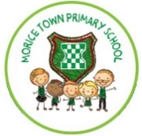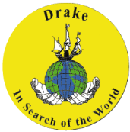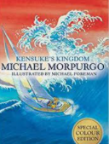

**Purpose/Audience:**

1. Compare and contrast
2. Share with Year 6 children at Drake (type and email)
3. Share debate with the whole class and other groups. Engage in answering difficult questions.
4. Entertaining and educating – video record and share on school You Tube channel.
5. Engage story lovers in history.
6. Understand different perspectives during a war,
7. Post to Yr6 pupils of Drake Primary School. Await a response with feedback.
8. Display in school for others to enjoy.

**Outcomes:**

1. Two contrasting ‘King’ profile fact sheets: **Viking and Anglo-Saxon**.
2. Comparison report of laws and justice between **Vikings and Anglo-Saxons.**
3. To present a debate to whether the **Vikings** were raiders or traders (Power Point)
4. To write a **Viking** poem based on Dane-geld by Rudyard Kipling.
5. To write a mini saga based the **Viking** warrior Biorn entering Valhalla **(English unit)**
6. Write a diary entry from the perspective of a surviving soldier **(Norman Britain)** – GDS children write from an alternative perspective.
7. Write a formal letter from the perspective of Henry VIII asking explaining why he wants a divorce from Catherine of Aragon **(Tudor Britain)**
8. Write an informal (love) letter from the perspective of Henry VIII to one of his wives **(Tudor Britain)**

**Class reader:**

**ICT skills:**

* Typing and emailing documents
* PowerPoint presentation (Google slides)
* Record video of performing poem and upload to school You Tube channel
* Spreadsheets
* Scratch animation stories

**Geography skills:**

* Identify the settlements and homelands of the Vikings.
* Locate kingdoms of the Anglo-Saxons
* The location of The Battle of Hastings (Senlac Hill – Hastings) and The Battle at Stamford Bridge (Yorkshire).
* Using an atlas, locate Vatican City in Rome, Europe.

**History Skills:**Chronological historical knowledge of Britain.   
- Vikings and Anglo-Saxons (kings, invasions and settlements)- Normans (The Battle at Stamford Bridge and The Battle of Hastings 1066)   
- Tudor (Henry VII and his six wives/The Pope)

**Art/DT skills:**- Designing and constructing a Viking Longboat.  
- Sewing a Tudor rose (exploring different stitches and joining).   
-Explore different mediums and evaluate the best choice for creating a family tree (Henry VIII).  
-Bayeux Tapestry recreation (focus on detail and tone whilst sketching).

**Year 6**

**Chronology**

**Visible Learning:**

Success criteria for extended writing and WAGOLLS