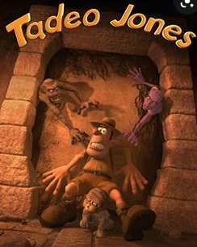
Setting description
Tadeo Jones hesitantly stepped into the crumbling pyramid and lit his heavy lantern. Wasting no time, he continued through the pyramid. After he heard a fear striking noise (a ghostly echo), he hurried into an enclosed hallway. At the end of the hallway, there was what looked like a maze with many passages. His eyes slowly scanned the room with much shock! Which passageway was he to take? After a while, Tadeo found a secret passage behind an Egyptian statue. Once he had entered, the door angrily slammed behind him.

On his right hand side, he saw a light switch. A light switch in a pyramid? Tadeo (who was now intrigued) flicked the switch. All of a sudden, the hallway lit up with flickering flames. Very confused, he threw his lantern onto the floor. Once the lantern hit the ground, it made a loud clash, which echoed through the pyramid. What was waiting for Tadeo around the corner?

Tadeo edged into the second chamber. At first, he saw three sarcophaguses lined up perfectly - all in gold but then something else caught his eye. A golden artefact (Anubis). He picked it up and flung it into the air; it was as light as a feather.

In front of Tadeo, stood an engraved wall of old hieroglyphics, which seemed to tell an old, short story but with pictures and confusing symbols. As he was glancing at the wall, Tadeo walked backwards into a metal lever. For a short second it scared him. Tadeo then forcefully twisted the lever to see what it did. To get himself ready, he gripped one hand on the sandy wall.

Quickly the wall shot up and revealed priceless amounts of gold what he did not know was that the lever also opened the sarcophaguses. Tadeo stretched far across from the wall; It was barely out if reach. Tadeo was then shocked to his core as he saw a gaunt mummy crawling across the floor. Tadeo then fell and lost control of the lever. The wall then slammed shut. How was Tadeo going to safely leave the pyramid with the treasure?

