ERIC answers:
Disaster strikes:
Monday 22nd February: Rex Retrieval
- Hundreds of years
- Figs and olive trees
- 17
- His friend, Rectina
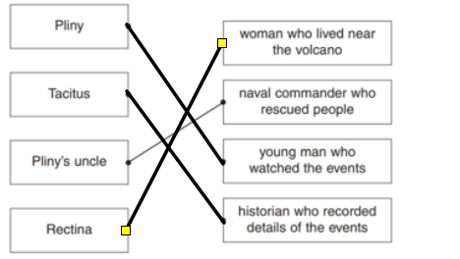

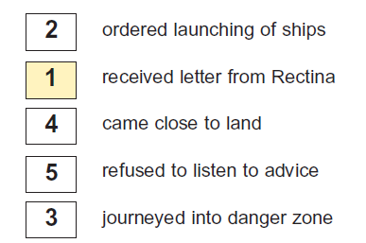

- ROARR: His uncle died in the eruption.

Tuesday 23rd February: Vocabulary Victor
- This tells us that the volcano had been ‘sleeping’ for hundreds of years, it was not active.
- A) Black B) This gives the reader the impression that the cloud is dangerous and full of smoke, ash and rock.
- Beg or plead
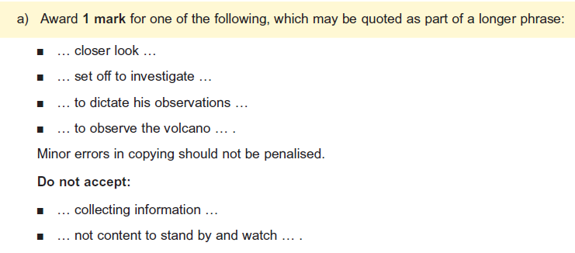

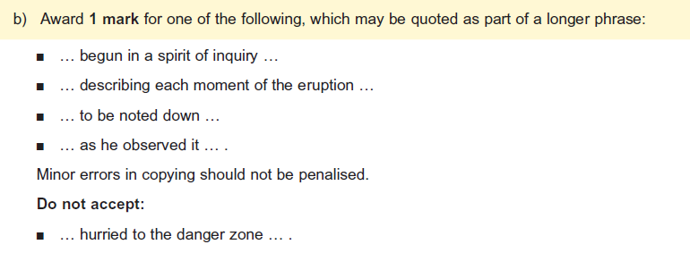

- ROARR:
- ,whose house was at the foot of the mountain and whose escape was impossible except by boat.
- Rectina
- The relative clause tells the reader extra information about Rectina and where her house is located.

Wednesday 24th February: Inference Iggy
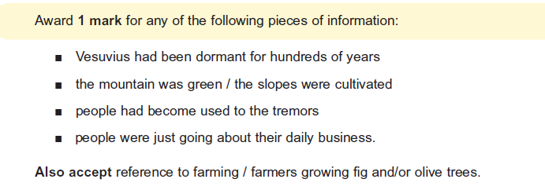
- Any of the following:

- Most people went about their daily business.
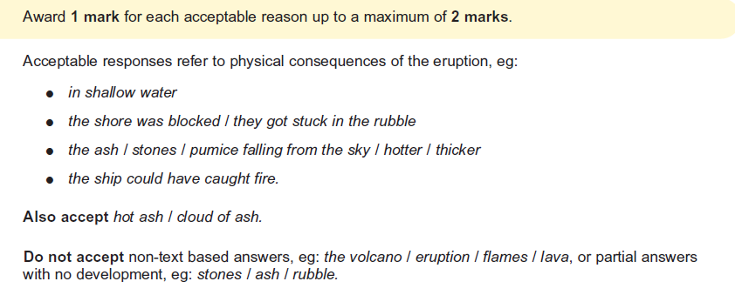
- This gives the reader the impression that Pliny’s uncle was brave and he was willing to sacrifice his life in order to save/rescue people from the eruption. He was courageous.

- The role of the scribe was important because this created evidence, a recount of the historic events that are studied by historians today.

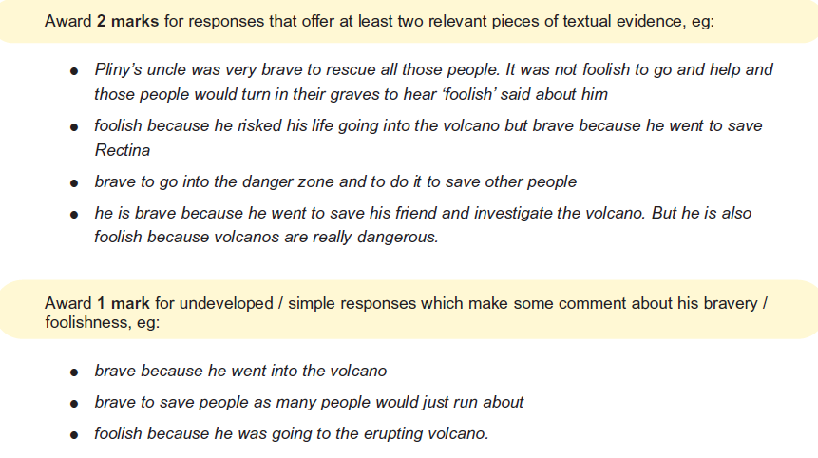
Thursday 25th February: Arlo author
