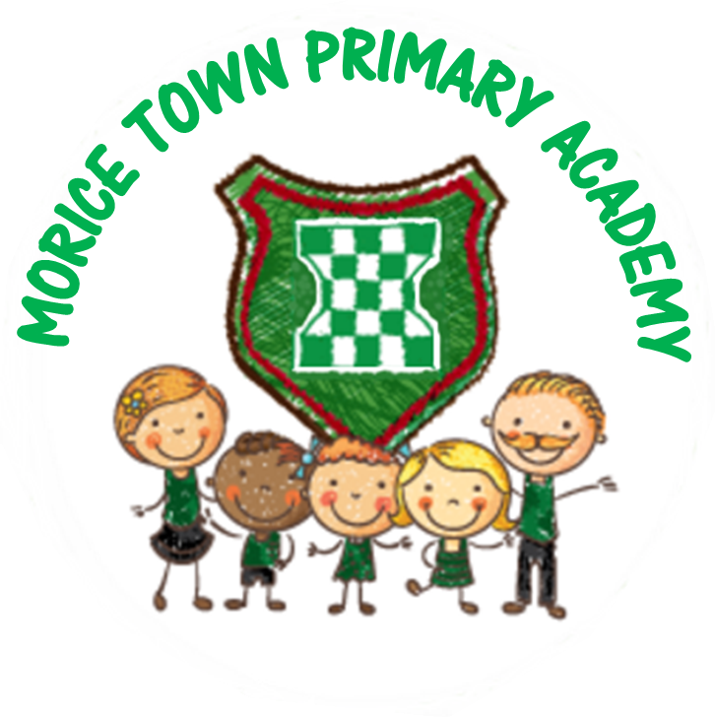

- Drake & Morice Town Primary Academies Knowledge & Skill Organiser - Long Ago and Chinese New Year Date- 08.01.2020-14.02.2020
 | Key Learning Outcomes | Activities
PSED | • I can understand that my own actions affect other people.  • I can understand how to follow school rules and why it is important.  • I can understand how to share with my friends.  Early Learning Goal  Children talk about how they and others show feelings, talk about their own and others’ behaviour, and its consequences, and know that some behaviour is unacceptable. They work as part of a group or class, and understand and follow the rules. They adjust their behaviour to different situations, and take changes of routine in their stride. | Continue to inspire good learning behaviour and confidence through ROARR.  Use ‘Are You Ready To Listen?’ visual prompts.  Each group to have their own area to tidy up and positive reinforcement will be given.  Golden Tickets linked to learning behaviour.  Reward system linked to classroom behaviour.  Hot seat characters from books to talk about their feelings.  Adults in CP to model positive behaviour (record observations and add to Tapestry)  Areas of CP to encourage children to share equipment.  How to look after our class bear.
CAL | • I can concentrate on an activity.  • I can listen and play at the same time.  Early Learning Goal  Children listen attentively in a range of situations. They listen to stories, accurately anticipating key events and respond to what they hear with relevant comments, questions or actions. They give their attention to what others say and respond appropriately, while engaged in another activity. | Dinosaur enhancement for Small World.  Talk partners during carpet time.  Hot seating characters from stories.  Talk for Writing/Story time using - The Day Louis Got Eaten, The Dinosaur, Stomp Dinosaur Stomp, Rex, My Dinosaurs, Bumpus Jumpus Dinosaurumpus, How To Grow A Dinosaur, Tyrannosaurus Drip, The Littlest Dinosaurs Big Adventure, Say Hello To The Dinosaurs, Dinosaur Roar, Rumble With The Dinosaurs, Dinosaur Doo, Mad About Dinosaurs, How Dinosaurs Really Work, Tom And The Island Of Dinosaurs.  Focus on colourful semantics during Literacy (who, what doing, what).  Talking points (pictures) and books.  Story Sacks  Role Play  Story scribing, children add pictures and small group’s role play together.  Speech and Language intervention.  Shadow puppet dinosaurs.  Shrove Tuesday (Pancake day).
PD | • I can use tools and materials safely and with increasing control.  • I can use a preferred hand to carry out different activities.  • I can start to retrace patterns when drawing  • I can form recognisable letters.  • I can hold a pencil properly.  I can use the toilet independently.  Early Learning Goal  Children show good control and co-ordination in large and small movements. They handle equipment and tools effectively, including pencils for writing. | Handwriting using chalk, shaving foam, large crayons.  Bikes and vehicles.  Large Construction.  Workshop resources such as scissor’s, tape, split pins, hole punchers.  Volcano dance for Squiggle As You Wiggle linked to zigzag letters.  Dinosaur dance- Diplodocus for slow line movements link to ladder letters and Pterodactyl dance for swooping figure 8 movements link to curly letters.  Chalking big dinosaur shapes.  Making small dinosaur skeletons using cotton buds.  Finger gym activities: treasury tags and hole punchers making moving dinosaurs using split pins etc.  Chinese food (Chinese New Year) and using chopsticks.  Fruit smoothies/kebabs.
Literacy | • I can give meaning to marks.  • I can hear and say the initial sound in words.  • I can segment the sounds in simple words and blend them together.  • I can link sounds to letters, naming and sounding the letters of the alphabet.  • I can use some clearly identifiable letters to communicate meaning.  • I can write my own name and other things such as labels, captions and sentences.  • I can write short sentences in meaningful contexts.  Early Learning Goal  Children use their phonic knowledge to write words in ways which match their spoken sounds. They also write some irregular common words. They write simple sentences which can be read by themselves and others. Some words are spelt correctly and others are phonetically plausible. | Books linked to the topic.  Segmenting and blending CVC words / alien word games (real and alien words).  Phonic bingo  Phonic work daily whole class and small groups.  Story time  Mark making using large rolls of paper, magnetic letters.  Reading Area / Role Play / Small World.  Retelling the stories that are linked to the topic.  Guided Group Work:  Week 1: Christmas News  Week 2: Tom and the Island of Dinosaurs  Week 3: Tom and the Island of Dinosaurs  Week 4: Dinosaur fact writing (become a dinosaur)  Week 5: Dinosaur Roar (rhyming focus)  Week 6: Chinese New Year
Maths | • I can use words such as ‘more’ and ‘fewer’ to compare two sets of objects.  • I can find the total number of items in two groups by counting all of them.  • I can find the number that is one more than a given number.  • I can find one more or one less from a group of up to five objects, then ten objects.  • I can begin to talk about adding and subtracting. discussion,  • I can record using marks and talk about it.  • I can identify mathematical problems based on own interests.  • I can use objects and shapes to create patterns and build models.  • I can use language related to time.  • I can use language related to money.  Early Learning Goal  Children count reliably with numbers from one to 20, place them in order and say which number is one more or one less than a given number. Using quantities and objects, they add and subtract two single-digit numbers and count on or back to find the answer. They solve problems, including doubling, halving and sharing.  Early Learning Goal  Children use everyday language to talk about size, weight, capacity, position, distance, time and money to compare quantities and objects and to solve problems. They recognise, create and describe patterns. They explore characteristics of everyday objects and shapes and use mathematical language to describe them. | The Same But Different Maths / Odd One Out.  Shape pictures of dinosaurs using prepositional language (on top of, behind etc.)  Capacity – Water Station.  1 minute timed challenges.  Outside number line/numbers to order.  Number formation.  Part-Part Whole Model – chalks/beanbags in hoops.  Dice  Numbered animals/ games.  Number targets- shoot the correct number.  Calendar and clock in the home corner.  Weighing out food in the home corner.  Patterns using dinosaur prints.  Tally charts for dinosaurs.  Week 1: Measuring time  Week 2: Number bonds to 5  Week 3: 1:1 correspondence to 8  Week 4: 1:1 correspondence to 10  Week 5: Comparing and combining groups  Week 6: Number bonds to 10
UW | • I can ask questions about the world (where I live). I can talk about what I have observed in my world.  • I can talk about why things happen and how things work.  • I can understand growth, decay and changes over time.  • I can care for animals and the environment. I can observe similarities, differences, patterns and change. Early Learning Goal Children know about similarities and differences in relation to places, objects, materials and living things. They talk about the features of their own immediate environment and how environments might vary from one another. They make observations of animals and plants and explain why some things occur, and talk about changes. | Beebots  Chinese New Year- trip to a local Chinese shop.  Discussing traditions and events around festivals.  Encourage children to take photos and video clips of friends/ make up own story lines.  Dinosaurs Facts  Audio books with CD player in reading area.  Non-fiction videos to find out dinosaur facts.  Make Pancakes (Shrove Tuesday).  Valentine’s Day  Big model making using boxes etc to make group dinosaurs.  Exploring dinosaur facts together.  Make and explode a volcano.  Dragon dancing
EAD | • I can create simple representations of events, people and objects.  • I can choose particular colours to use for a purpose.  • I can introduce a storyline or narrative into my play.  • I can play alongside other children.  • I can imitate movement in response to music.  • I can tap out simple repeated rhythms.  • I can explore and learn how sounds can be changed.  Early Learning Goal  Children use what they have learnt about media and materials in original ways, thinking about uses and purposes. They represent their own ideas, thoughts and feelings through design and technology, art, music, dance, role play and stories. | Exploring printing with hands/ fingers/ stampers/ making print boards.  Small world and role play (CAL).  Making props for role play area at Paint & Create Station.  Musical instruments (following Active Music scheme).  Shadow dinosaur puppets.  Junk modelling dinosaurs (plan, do, review) how can we make our model even better?  Making models at The Paint Create Station - Focus on joining skills, use hole punchers/treasury tags and spit pins.  Transient art making dinosaurs & Chinese Patterns / dinosaurs using play dough  Dragon dancing  Chinese New Year music.  Story scribing for role play/encourage children to act out stories.  Kitchen role play.  Dinosaur puppet making.  Making footprints using hand etc.  Painting dinosaur worlds.  Construction Station  Large Construction area – patio.  Colour mixing and making dragons.

