Setting description
Todeo Jones dangerously stepped into the mysterious, ancient pyramid and lit up his dim rusty, old lantern without a struggle. He heard a ghostly echo from an unusual noise in the chamber. When he entered the next chamber there were a variety of passageways. Thinking where does he go now? He ambled to an ancient statue that revealed a secret passageway. Once he entered, the door it aggressively slammed behind him; just millimetres away from his back.
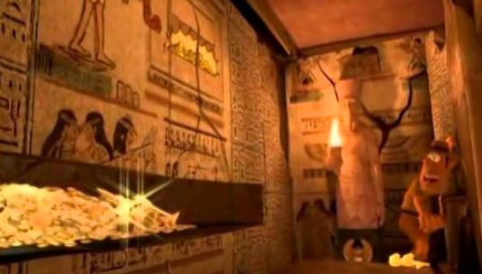
On his right hand side, there was a mouldy light switch. He repeatedly switched the light until he threw his lantern. What was waiting for him? As he walked towards the end, the flames danced in the air.

Todeo Jones wandered in to the second chamber. When he gazed around, his eye caught a shimmering artefact, which had a jackal head (from Anubis the god of mummification).He picked it up, tossed it and caught it as if it was weightless.

In front of Todeo was an embellished wall of hieroglyphics telling a story; he stumbled into a peculiar lever. He unknowingly rotated the lever and it was very loose.

Within minutes, the wall revealed mounts, mounts and mounts of gold coins. He disconnected with the lever then the wall sealed shut - fingertips away. Then a gaunt, deserted baby mummy come out of the sarcophagus. Will he get out?

