 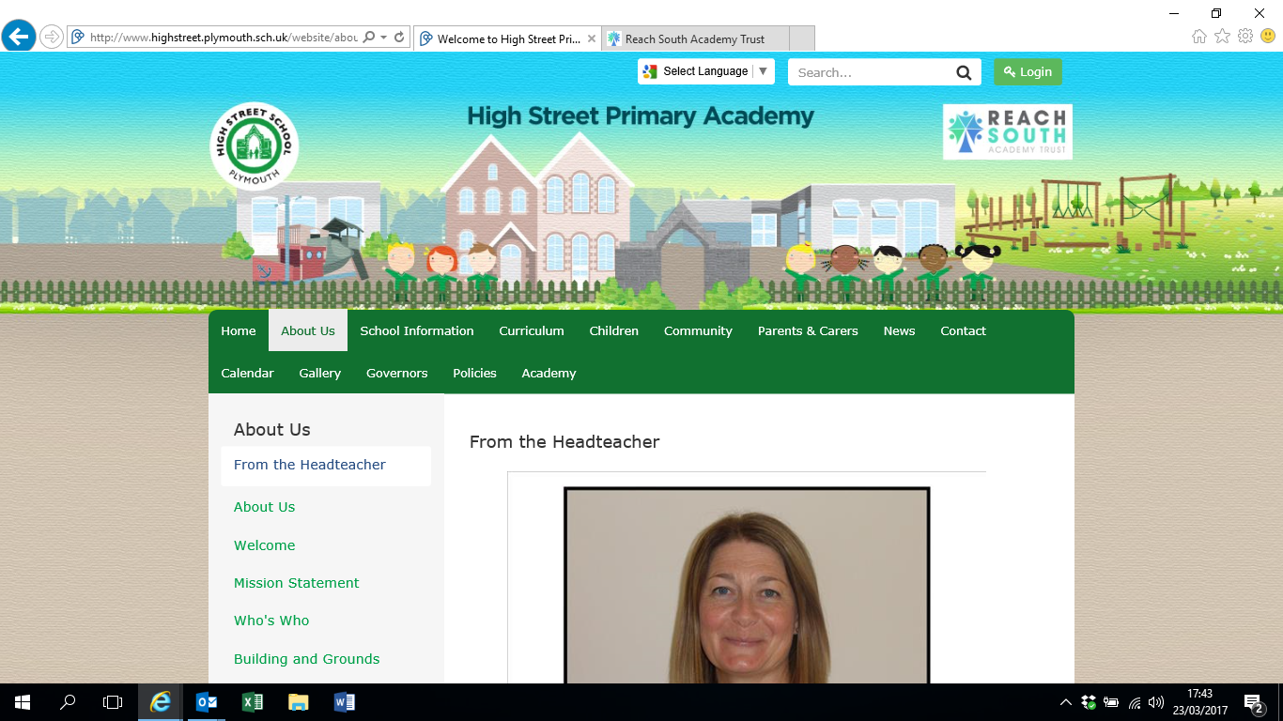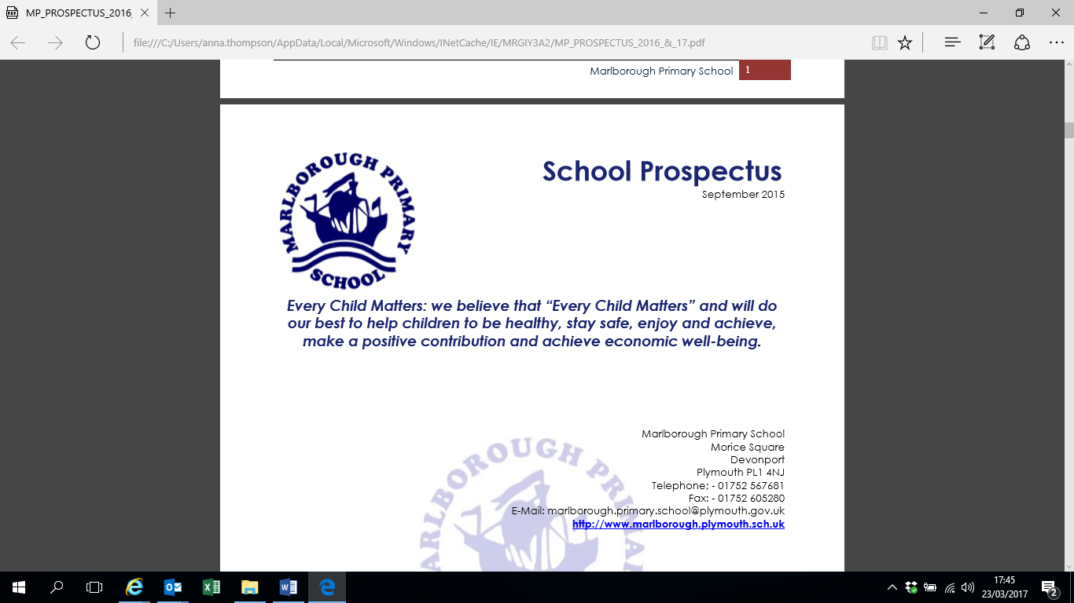

[](http://www.moricetownprimary.co.uk/)

|  |  |  |  |
| --- | --- | --- | --- |
| Key notes – ADMISSION ARRANGEMENTS 2019/2020 | | | |
| School name | | 1. Drake Primary Academy 2. Goosewell Primary Academy 3. High Street Primary Academy 4. Marlborough Primary Academy 5. Morice Town Primary Academy 6. Pilgrim Primary Academy 7. Stoke Damerel Primary School   Stuart Road Primary School | |
| Admission authority | | The Trust Board of the Reach South Multi Academy Trust  The admissions function has been delegated to the Local Governing Body of each individual Primary School named above | |
| School status | | Academy | |
| Catchment area | | No | |
| Supplementary Information Form | | Yes – parents who are members of staff only | |
| Application forms available online | | [www.plymouth.gov.uk/schooladmissions](http://www.plymouth.gov.uk/schooladmissions) | |
|  | Normal point of entry | | In-Year admission |
| Age range for application | 1 September 2014 - 31 August 2015 | | Any admission other than the normal point of entry in years Reception/Foundation – year 6 |
| Application period | Monday 5 November 2018 – 15 January 2019 | | From Sunday 1 September 2019 |
| Offer date | Tuesday 16 April 2019 | | Within 20 school days of application receipt |
| Published admission number | See section 3 below | | Unless otherwise agreed, the published admission number at the normal point of entry applies to each year group as it moves through the school |

**Index**

section 1

1. Application process for Reception/Foundation admissions (normal point of entry)
2. Application process for in-year admissions

section 2

1. Oversubscription criteria for normal point of entry and in-year admissions
2. Staff supplementary information form

SECTION 3

Published admission number (PAN)

**ADMISSION ARRANGEMENTS: REACH SOUTH MULTI ACADEMY TRUST**

# The Trust Board of the Reach South Multi Academy Trust is the admission authority for Drake Primary Academy, Goosewell Primary Academy, High Street Primary Academy, Marlborough Primary Academy, Morice Town Primary Academy, Pilgrim Primary Academy, Stoke Damerel Primary School and Stuart Road Primary School. The admission authority will comply with provisions within the School Admissions Code and the School Appeals Code available at [www.gov.uk/government/publications/school-admissions-code--2](http://www.gov.uk/government/publications/school-admissions-code--2).

# The admission arrangements outlined within this document apply to admissions in the 2019/2020 academic year.

**SECTION 1**

1. **(i) Reception/Foundation admissions (normal point of entry)**

The admission arrangements outlined within this section apply to children starting in the Reception/Foundation Year for the first time in 2019/2020. The published admission number (PAN) for this year group is shown in the school list at Section 3 and in the Starting School guide for parents. The closing date for application is 15 January 2019. Allocation results will be notified on 16 April 2019. The admission authority follows Plymouth City Council’s coordinated primary admissions scheme available at [www.plymouth.gov.uk/schooladmissions](http://www.plymouth.gov.uk/schooladmissions).

All applicants must:

1. Complete the Common Application Form available from, and returnable to their home local authority;
2. In addition, applicants applying under criteria 4 below must complete the staff supplementary information form and return it direct to the School Admissions Team, Plymouth City Council1.
3. **(ii) In-Year admissions (admissions outside the normal point of entry)**
4. The admission arrangements outlined within this section apply to in-year admissions during the 2019/2020 academic year.
5. An In-Year admission is any entry to school other than at the normal point, for example, transferring school due to a house move or for other personal reason. Requests for admission to Reception made after the normal round of admissions – after 31 August 2019 – and requests for places in other year groups should be made direct to Plymouth City Council1.
6. With the exception of a child with an Education, Health and Care Plan (EHCP), all applications will be considered under Plymouth City Council’s Fair Access Protocol.
7. Application should be made via Plymouth City Council1 at [www.plymouth.gov.uk/schooladmissions](http://www.plymouth.gov.uk/schooladmissions). Reach South Multi Academy Trust follows Plymouth City Council’s local coordinated in-year admissions scheme available at [www.plymouth.gov.uk/schooladmissions](http://www.plymouth.gov.uk/schooladmissions).
8. All applicants must:
9. Complete the Common Application Form available from and returnable to Plymouth City Council1;
10. In addition, applicants applying under oversubscription criteria 4 must complete the staff supplementary information form and return it direct to the School Admissions Team, Plymouth City Council1.
11. Unless otherwise agreed, the published admission number applies to each year group as it moves through the school. The close date for application is the end of each working day. Offers should be made within twenty school days of the application submission date.

**SECTION 2**

**Oversubscription criteria for Plymouth primary schools within the Reach South Multi Academy Trust for normal point of entry and in-year admissions**

A child with an Education, Health and Care Plan (EHCP) which names the school will be admitted.

At the normal point of entry, where there are fewer applicants than the PAN, all children will be admitted unless they can be offered a higher ranked preference. For in-year admissions where there is space in the school, all children will be admitted unless the school can demonstrate that admission would prejudice provision of efficient education or efficient use of resources.

In the event that the School is oversubscribed, the admission authority will apply the following oversubscription criteria in order of priority:

1. **Looked after childrenand all previously looked after children.** A 'looked after child' is a child who is (a) in the care of a local authority, or (b) being provided with accommodation by a local authority in the exercise of their social services functions (see the definition in Section 22(1) of the Children Act 1989) at the time of making an application to a school. Previously looked after children are children who were looked after, but ceased to be so because they were adopted (or became subject to a child arrangements order or special guardianship order);
2. **A child with exceptional medical or social grounds**. Applicants will only be considered under this heading if the parent/carer or their representative can demonstrate that only the preferred school can meet the exceptional medical or social needs of the child. This can be in the form of a testimony from a medical practitioner, social worker or other professional who can support the application on an 'exceptional' basis.

Exceptional medical or social grounds could include, for example:

* a serious medical condition, which can be supported by medical evidence
* a significant caring role for the child which can be supported by evidence from social services;

1. **Children with a sibling already attending the school at the time of admission**. Children will be classed as siblings if they live in the same household in a single family unit. This includes for example, full, half, step, or adoptive brothers or sisters;
2. **Children whose parent/carer is a member of staff employed on a permanent contract by the school** for two or more years at the time at which the application for admission to the school is made or where the member of staff is recruited to fill a vacant post for which there is a demonstrable skill shortage evidenced by completion of the staff supplementary information form1. (This covers staff working at the school to which the application relates but does not include staff who work on the school site for other employers);
3. **Other children** not shown in a higher oversubscription criteria.

**NOTES:**

**Admission out of the normal age group:** Places will normally be offered in the year group according to the child’s date of birth but a parent may submit an application for a year group other than the child’s chronological year group. A decision will be made on the basis of the circumstances of each case and in the best interests of the child concerned. This will include taking account of the parent’s views; information about the child’s academic, social and emotional development; where relevant, their medical history and the views of a medical professional; whether they have previously been educated out of their normal age group; and whether they may naturally have fallen into a lower age group if it were not for being born prematurely. The admission authority will also take into account the views of the head teacher of the school(s) concerned. Parents must not assume that the decision of one school will transfer with the child to a different school as the decision rests with the individual admission authority. Where a place is refused in a different year group but a place is offered in the school, there will be no right of appeal.

**Appeals:** In the event that an applicant is denied a place at the school, the parent/carer will have the right of appeal to an independent appeal panel. Information relating to the appeal process can be obtained from Plymouth City Council’s School Admissions Team1.

1. **Fraudulent applications/withdrawal of allocated places:** The School Admissions Code allows an offer of a school place to be withdrawn if:

* it has been offered in error or
* a parent has not responded within a reasonable period of time or
* it is established that the offer was obtained through a fraudulent or intentionally misleading application. An example of this would be knowingly using an incorrect home address for a child. In these cases the application would be considered using the information that the local authority believes to be correct, for example using the home address where the local authority considers that the child actually lives.

1. All suspected fraudulent applications will be investigated and if a case is found, it could lead to criminal prosecution.

**Home address:** Any allegations received by the admission authority of people providing false or accommodation addresses when applying for school places shall be fully investigated and, if found to be true, it could lead to a criminal prosecution and withdrawal of an allocated place. Schools have been advised by Plymouth City Council to ask parents/carers to provide proof of residence (for example utility bills) before admitting a child. Plymouth local authority (LA) will also carry out checks as appropriate1. A child's home address is defined as the address at which the child is normally resident or, where a child lives at more than one address, the address at which the child lives for the majority of the time. Where the home address is unclear, the Admission Authority will determine the appropriate address taking into account factors such as the address to which the Child Benefit Allowance or Child Tax Credit is payable, registration for medical services etc.

**Mode of study and start date:** There is a legal requirement that all children begin full time education by the beginning of the term following their fifth birthday, this is referred to as compulsory school age. Places are offered to children for admission at the beginning of the September term after the fourth birthday. That is before they reach compulsory school age.

Parents have a right to defer the date their child is admitted, or to take the place up part-time, until the child reaches compulsory school age. The place that was offered would be held open for them at the school. Places cannot be deferred and held open beyond the beginning of the final term of the school year for which the offer was made. If you decide that admission will be deferred, you must tell the allocated school so that the place can be held open. Where a parent does not inform the school that admission is to be deferred and does not admit the child at the expected point, it is likely that the place will be withdrawn and offered to another child.

For normal point of entry: the expected point of admission will be September 2019.

For in-year admissions: the expected point of admission will be within two weeks of the of the date of the allocation or within six weeks of the original application whichever is the later (unless other arrangements have been made with the school).

**Multiple births:** Defined as the birth of more than one baby from a single pregnancy. We understand that parents/carers would like to keep twins, triplets and other children of multiple birth together. Where the admission criteria is applied and it is not possible to offer places to all children of the same multiple birth family we would work with the family to find the best solution for them and their children. Should it transpire that it is not possible to offer place(s) to all children within that multiple birth, the parent/carer will be invited to nominate which child should be allocated the place.

**Response:** Parents/carers must respond to an allocation of a school place within two weeks of the date of notification of availability of a school place or, in the case of an in-year admission, within six school weeks of the original application for a school place whichever is the later. Response must be made to Plymouth City Council1. In the absence of a response, the offer may be revoked and the place may be reallocated to someone else.

**Tie Breaker:** Where we have to choose between two or more children in the same category as each other, priority will be determined on the basis of distance between home and school. Measurements are taken by a straight line on a map using Plymouth City Council's electronic mapping system1 – the shorter the distance the higher the priority. Measurement points will be from the spatial locator identified by the National Land and Property Gazetteer. The spatial locator is the address point based on a general internal point. Flats are therefore taken to be the same measurement point regardless of floor of location. If the tie-breaker is not sufficient to distinguish between applicants in a particular category, there will be a random ballot as set out in the School Admissions Code. This will be undertaken by the Chair of Governors in the presence of the head teacher by the operation of an electronic random number generator.

**Waiting lists:** If a place cannot be offered at the preferred school at the normal point of entry, the child’s name will automatically be added to the waiting list for any school ranked higher than the school allocated.Those on a waiting list and late applicants will be treated equally and placed on the same list.Waiting lists will be held in the order of the published admission criteriaand will be maintained until the end of the summer holidays 2019 in respect of the normal point of entry. Any vacancies that arise will be allocated to the child at the top of the waiting list.

From 1 September 2019, the in-year admissions scheme applies and the waiting list procedure will change in that parent/carers will be asked if they wish their child to be added to a waiting list and to confirm their wish for their child to remain on a waiting list in order that the list can be kept up to date.

**STAFF SUPPLEMENTARY INFORMATION FORM 2019/2020**

Please note this is a supplementary information form for administration purposes only and is not an application form. It will used to rank a submitted application according to the published admission criteria.

|  |
| --- |
| Only complete this form if you are:   1. A member of staff employed on a permanent contract by the school (and working at the school applied for) for two or more years at the time at which the application for admission to the school is made;   or   1. A member of staff recruited to fill a vacant post for which there is a demonstrable skill shortage. |

If you are applying under a) or b) above, complete this form and return it to the School Admissions Team, Education, Participation and Skills, Plymouth City Council, Windsor House, Tavistock Road Plymouth, PL6 5UF.

**To be completed by the parent/carer**

|  |  |
| --- | --- |
| Child’s full name: |  |
| Date of birth: |  |
| Member of staff employed by the school: |  |
| Name of school: |  |
| Name of parent/carer: |  |
| Relationship to child: |  |
| Signature: |  |
| Date: |  |

Data Protection

All information supplied will be processed and held by Plymouth City Council. Information may be shared with other relevant admission authorities and Government Departments where there is a Legal requirement to do so.

**SECTION 3**

**Published admission number (PAN)**

|  |  |  |
| --- | --- | --- |
| **Primary School** | **2018/2019** | **2019/2020** |
| Drake Primary Academy | 30 | 30 |
| Goosewell Primary Academy | 90 | 90 |
| High Street Primary Academy | 30 | 30 |
| Marlborough Primary Academy | 30 | 30 |
| Morice Town Primary Academy | 30 | 30 |
| Pilgrim Primary Academy | 60 | 60 |
| Stoke Damerel Primary School | 60 | 60 |
| Stuart Road Primary School | 30 | 30 |

**CONTACTS AND FURTHER INFORMATION**

**REACH SOUTH MULTI ACADEMY TRUST**

Telephone: 01283 246433

[info@reachsouth.org](mailto:info@reachsouth.org)

**Drake Primary Academy**

1 Johnston Terrace Ope

Keyham

Plymouth

PL2 2EN

Telephone: 01752 567649

[drake.primary.school@plymouth.gov.uk](mailto:drake.primary.school@plymouth.gov.uk)

[www.drakeprimaryschool.co.uk](http://www.drakeprimaryschool.co.uk)

**Goosewell Primary Academy**

Goosewell Road

Plymstock

Plymouth

Plymouth

PL9 9HD

Telephone: 01752 482960

[admin@goosewell.plymouth.sch.uk](mailto:goosewell.primary.school@plymouth.gov.uk)

[www.goosewell.plymouth.sch.uk](http://www.goosewell.plymouth.sch.uk)

**High Street Primary Academy**

High Street

Stonehouse

Plymouth

Devon

PL1 3SJ

Telephone: 01752 225649

[high.st.primary.school@plymouth.gov.uk](mailto:high.st.primary.school@plymouth.gov.uk)

[www.highstreet.plymouth.sch.uk](http://www.highstreet.plymouth.sch.uk/)

**Marlborough Primary Academy**

Morice Square

Devonport

Plymouth

PL1 4NJ

Telephone: 01752 567681

[marlborough.primary.school@plymouth.gov.uk](mailto:marlborough.primary.school@plymouth.gov.uk)

[www.marlborough.plymouth.sch.uk](http://www.marlborough.plymouth.sch.uk)

**Morice Town Primary Academy**

Charlotte Street

Devonport

Plymouth

PL2 1RJ

Telephone: 01752 567609

[morice.town.primary.school@plymouth.gov.uk](mailto:morice.town.primary.school@plymouth.gov.uk)

[www.moricetown.plymouth.sch.uk](http://www.moricetown.plymouth.sch.uk)

**Pilgrim Primary Academy**

Oxford Street

Plymouth

PL1 5BQ

Telephone: 01752 225319

[contactus@ppsonline.org](mailto:contactus@ppsonline.org)

[www.pilgrimprimaryschool.co.uk](http://www.pilgrimprimaryschool.co.uk)

**Stoke Damerel Primary School**

Collingwood Road

Stoke

Plymouth

PL1 5PA

Telephone: 01752 567686

[stoke.damerel.primary.school@plymouth.gov.uk](mailto:stoke.damerel.primary.school@plymouth.gov.uk)

[www.sdps.co.uk](http://www.sdps.co.uk)

**Stuart Road Primary School**

Palmerston Street

Stoke

Plymouth

PL1 5LL

Telephone: 01752 567668

[admin@srps.plymouth.sch.uk](mailto:admin@srps.plymouth.sch.uk)

[www.stuartroad.org](http://www.stuartroad.org)

**Plymouth School Admissions Team**

Year Reception/Foundation intake at the normal point of entry: 01752 307166

In-Year admissions: Telephone Primary 01752 307170 or 307110

The website at [www.plymouth.gov.uk/schooladmissions](http://www.plymouth.gov.uk/schooladmissions) has information about applying for a place at the school, school appeals, and the coordinated schemes of admission.

**School Appeals**

Telephone 01752 398164

**Inclusion, Attendance and Welfare Service**

Telephone 01752 307405

[www.plymouth.gov.uk/schoolsandeducation/attendancebehaviourandwelfare](http://www.plymouth.gov.uk/schoolsandeducation/attendancebehaviourandwelfare)

**The Department for Education Schools (DFE)**

Telephone: 0370 000 2288

[www.education.gov.uk](http://www.education.gov.uk)

**Office of the Schools Adjudicator**

[www.education.gov.uk/schoolsadjudicator](http://www.education.gov.uk/schoolsadjudicator)

**Plymouth Information, Advice and Support for SEND**

Telephone 01752 258933 or 0800 953 1131

[www.plymouthias.org.uk](http://www.plymouthias.org.uk)