Correct the Spelling Mistake

Your Challenge…
Please write the sentences in your neatest handwriting (exactly as they are written, even with the spelling mistake) and then at the end of the sentence, please write the correct spelling. Try to do this without using the Year 3 and 4 Statutory Spelling List sheet but if you do need it, that’s fine!

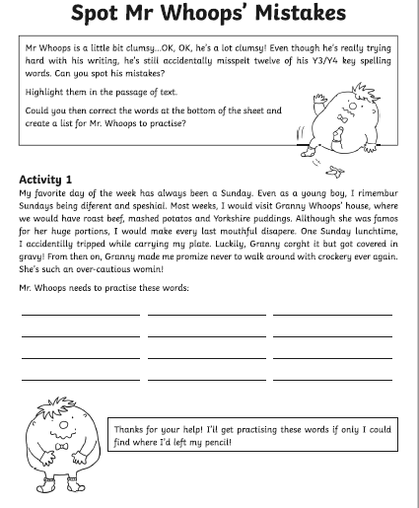

Remember…
Please remember to use your neatest handwriting during this activity!

