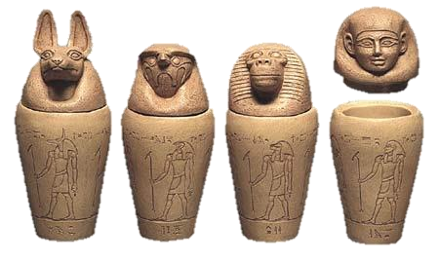***Ancient*** ***Egyptians Knowledge Organiser*** ***Year*** ***6***

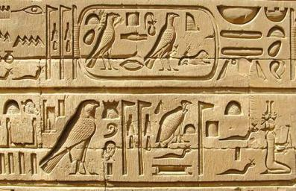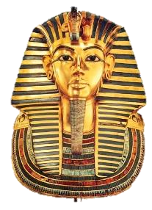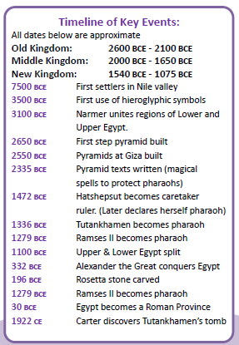

|  |  |  |  |  |  |  |  |  |
| --- | --- | --- | --- | --- | --- | --- | --- | --- |
|  | **Term** | | **Definition** | | | | | |
| *1* | *Afterlife* | | *The* *place* *where* *Egyptians* *believed* *they* *would* *go* *after* *they* *died.* | | | | | |
| *2* | *Akhet* | | *The* *season* *of* *the* *year* *when* *the* *Nile* *river* *flooded.* *A* *very* *important* *time* *of* *year* *in* *the* *desert!* | | | | | |
| *3* | *Canopic* *jars* | | *Special* *jars* *that* *held* *the* *organs* *of* *a* *mummy* *including* *the* *lungs,* *intestines,* *liver* *and* *stomach* *(Right).* | | | | | |
| *4* | *Dynasty* | | *A* *period* *of* *rule* *when* *a* *series* *of* *Pharaohs* *all* *came* *from* *the* *same* *family.* | | | | | |
| *5* | *Egyptologist* | | *An* *archaeologist* *who* *focusses* *Ancient* *Egypt.* *Howard* *Carter* *discovered* *Tutankhamun’s* *tomb.* | | | | | |
| *6* | *Hieroglyphics* | | *A* *type* *of* *writing* *that* *used* *a* *combination* *of* *pictures* *and* *symbols* *(Right).* | | | | | |
| *7* | *Mummification* | | *The* *process* *of* *preserving* *a* *body* *after* *death* *in* *preparation* *for* *the* *afterlife.* | | | | | |
| *8* | *Papyrus* | | *A* *plant* *that* *grew* *on* *the* *banks* *of* *the* *Nile.* *It* *was* *used* *as* *an* *early* *version* *of* *paper.* | | | | | |
| *9* | *Pharaoh* | | *The* *supreme* *ruler* *of* *all* *of* *Ancient* *Egypt.* | | | | | |
| *10* | *Sarcophagus* | | *A* *large* *stone* *box* *that* *held* *a* *mummy’s* *coffin.* *Often* *richly* *decorated* *for* *Pharaohs.* | | | | | |
|  | | | | | | | | |
|  | | The River Nile has many uses including: flooding, transportation, harvesting crops and making papyrus papers. All the cities of Egypt are situated around the River Nile. | |  | **Famous** **&** **important** **Pharaohs** | | |  |
| **1** | ***Narmer*** | *Said* *to* *be* *the* *first* *Pharaoh* *of* *all* *Egypt,* *around* *3150* *BCE.* *Also* *known* *as* *Warrior* *Menes.* |
| **2** | ***Khufu*** | *Pharaoh* *responsible* *for* *the* *building* *of* *the* *Great* *Pyramid* *at* *Giza.* |
| **3** | ***Hatshepsut*** | *First* *and* *longest-reigning* *female* *Pharaoh.* |
| **4** | ***Tutankhamun*** | *Youngest* *Pharaoh,* *famed* *for* *his* *burial* *tomb* *in* *the* *Valley* *of* *the* *Kings* *(mask,* *left).* |
| **5** | ***Ramses*** ***II*** | *Often* *known* *as* *Ramses* *the* *Great,* *his* *mummy* *still* *rests* *in* *Cairo’s* *Egyptian* *Museum.* *Built* *more* *statues* *and* *temples* *than* *any* *other!* |
|  | | | | |
| **6** | ***Cleopatra*** ***VII*** | *Often* *considered* *the* *last* *Pharaoh* *of* *Egypt.* *Kept* *power* *by* *making* *alliances* *with* *famous* *Romans* *such* *as* *Mark* *Antony* *&* *Julius* *Caesar.* |

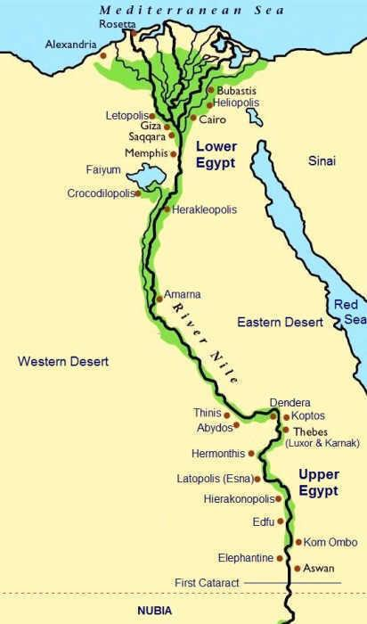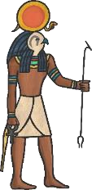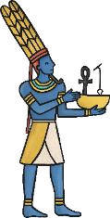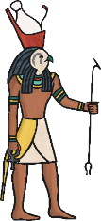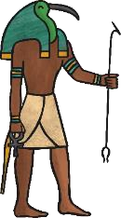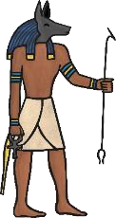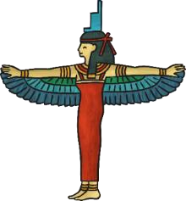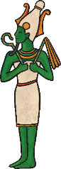

*The* *Valley* *of* *the* *Kings* *(where* *most* *Pharaohs* *were* *buried)* *was* *near* *Luxor,* *close* *to* *Thebes.*

**Amun** *King* *of* *the* *Gods*

**Ra** **Anubis** **Horus** **Thoth** *God* *of* *God* *of* *God* *of* *God* *of*

*the* *Sun* *Mummification* *the* *Sky* *Knowledge* **Isis**

*Mother* *Goddess,* **Key Gods (but** **Osiris** *Goddess* *of* **there were** *God* *of*

*Protection* *and* **MANY more)** *Death* *and*

*Healing* *the* *Afterlife*