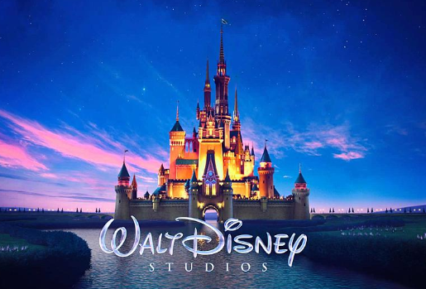

**History**

We will be focusing on exploring the history of animation. Researching the founder, Walt Disney, and looking at the advances in technology.

**Music**

Children will be looking at different songs from animation films produced by Disney and DreamWorks. These will be performed in our class assembly.

**Art & DT**

In Art, children will have the opportunity to sketch and paint their favourite animation characters. In DT, children will be making Disney themed cookies and learn how to sew Disney patches using felt materials.

**ICT**

Children will be learning how to create their own digital animation sequence.

**Science**

The children will be taught Science every Thursday by Mr Twynam. They will be building on their scientific skills exploring ‘Living things and their Habitats’ and ‘Animals including Humans’.

**Geography**

We will be learning about different islands around the world and locating them using an atlas. We will focus on The Lion King and look at the continent of Africa.

**English**

In English, the children will be writing a flashback story linked to Tarzan, a poem linked to How to Train your Dragon, a story with issues and dilemmas linked to Moana and a film review of The Lion King.

.

Diary dates

* Monday 6th May- bank holiday
* Week commencing Monday 13th May- SATs week
* Thursday 23rd May- Monday 3rd June- half term
* Friday 24th May- Non-pupil day
* Week commencing Monday 10th June- Sports Day
* Friday 14th June- Father’s day BBQ
* Week commencing Monday 1st July- Art week
* Thursday 4th July- Summer fayre
* Wednesday 24th July – Last day of term

**Theme**

The children will be Unpacking Animation. We will focus on Disney and DreamWorks. We will use these films to inspire great writing opportunities. This topic will enable us to learn about animation across the curriculum.

Theme: Unpacking Animation Date: Summer 2018/19

**Maths**The children will be expanding their knowledge, skills and application of percentages, decimals, properties of shape and converting units of measurement.

**RE**

Children will be learning about commitment. We will explore what this means in today’s society.

**PE**

We will be learning how to play hockey and exploring the events in athletics. We will also be continuing with REAL PE and focusing on health and fitness.

**PE days are Monday and Tuesday.**