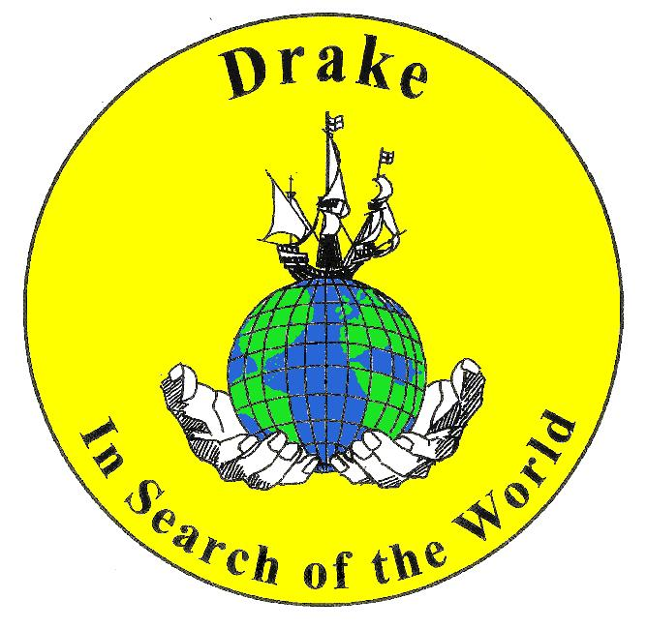
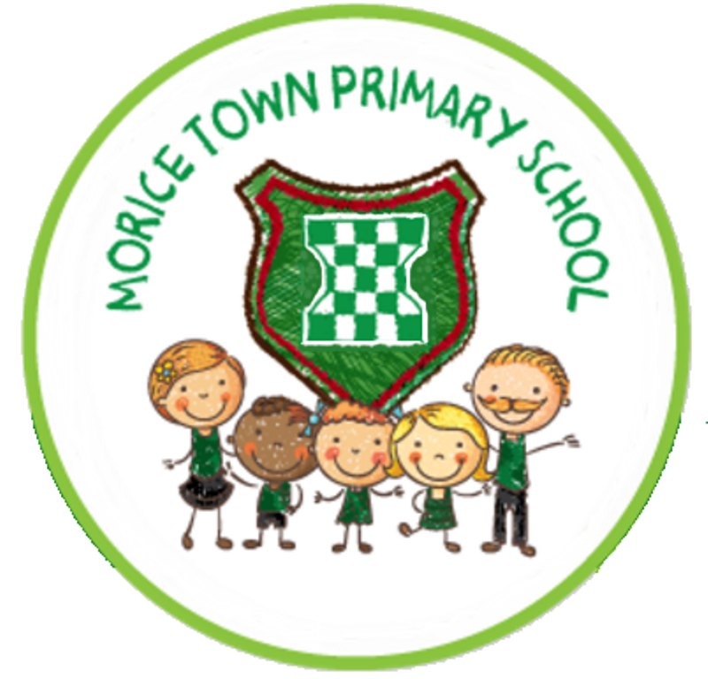
Drake & Morice Town Primary Academies’ Curriculum

Intent.
All pupils will leave Drake and Morice Town Primary Academies with the skills and knowledge to know ‘who they are and where they are in the world’. They will have a sense of place and purpose to thrive in a multicultural, diverse society.
All pupils have the right to fully access our curriculum and no group will be offered a reduced curriculum.
The intent of our school curriculum are:
- to enable all children to learn, and develop their skills, to the best of their ability;
- to promote a positive attitude towards learning, so that children enjoy coming to school, and acquire a solid basis for lifelong learning;
- to teach children the basic skills of English, maths and ICT;
- to enable children to be creative and to develop their own thinking;
- to teach children about the developing world, including how our environment and society have changed over time;
- to fulfil the requirements of the National Curriculum and the Locally Agreed Syllabus for Religious Education;
- to help children understand Britain's cultural heritage;
- develop an understanding of British values;
- to appreciate and value the positive contribution made by all ethnic groups in our multi-cultural society;
- to enable children to be positive, successful citizens;
- to teach children to have an awareness of their own spiritual development, and to distinguish right from wrong;
- to help children understand the importance of truth, fairness and democracy, so that they grow up committed to equal opportunities for all;
- to enable children to have respect for themselves and high self-esteem, and to live and work cooperatively with others.

Implementation
Our curriculum is broad and balanced, providing our children with purposeful and meaningful learning activities being underpinned by the National Curriculum. The schools’ curriculum is planned and sequenced so that new knowledge and skills build on what has been taught before. For example the youngest children learn about their nearest locality and most recent events in their lives. Each theme has clearly defined end points to prepare pupils for the next stage of their learning. Planned assessment opportunities identify pupils’ progress; misconceptions are timely addressed, securing long term memory.

The curriculum reflects the schools’ context by addressing typical gaps in pupils’ knowledge and skills:
- Early identification of children’s varied starting points.
- Tailored support to ensure children make rapid and sustained progress, eg speech and language therapy, ELSA, social skills groups, vocabulary development.
- The curriculum is sufficiently adapted to meet the needs of SEND pupils.
- Skills are taught in a progressive manner that is relevant to the context of the school.

Progressive thematic learning opportunities are carefully sequenced linking key skill development to pupils’ knowledge. Learning is linked and lessons are taught using a cross-curricular approach, however, where this is not achievable, subjects are taught discretely.
We place a strong emphasis on the development of the basic skills and their application in a range of contexts necessary to be confident independent learners. We plan our curriculum in phases. We agree a long-term plan for each key stage. This provides an overview of what topics and themes are to be taught in each term.
The medium-term plans identify the theme of the term’s work. A Knowledge Organiser/ overview sheet collates all the skills, knowledge and vocabulary to be taught identifying the end points. The termly grid lays out the work to be covered in each week or block of weeks.

The role of the subject leader
The role of the subject leader is to:
- provide a strategic lead and direction for the subject;
- support and advise colleagues on issues related to the subject;
- monitor pupils' attainment and progress in that subject area;
- provide efficient resource management for the subject.

It is the role of each subject leader to keep up to date with developments in their subject, at both national and local levels. They review the way in which the subject is taught in the school, and plan for improvement. This development planning links to whole-school development plan.

Impact
The impact of the curriculum is measured in standards achieved, progress made and personal qualities acquired. The impact of our curriculum is seen in:
- Pupils produce work of a consistent high standard.
- Pupils make positive progress from their given start points.
- Pupils achieve well in the standard assessment tasks when compared to the national benchmarks.
- Pupils enjoy memorable, worthwhile experiences developing their cultural capital.
- Pupils experience high quality teaching and successfully achieve their end points.
- Pupils display the schools learning dispositions (ROARR) and are ambitious about their own successes.
- Pupils are assessment capable learners who see assessment as a tool to accelerate their own progress.

Further guidance on the assessment arrangements can be found in the Reach South’s assessment policy.

Learning Dispositions
As well as teaching the requirements of the National Curriculum, children will be taught important attitudes to learning- learning dispositions to help them become successful adults.
ROARR
- Resilient
- Open
- Aspirational
- Resourceful
- Reflective

In our curriculum planning and feedback to children, we emphasise these skills, so that the children are aware of the skills they are using and developing.

