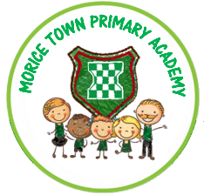

All About Me!

How high can you count? What numbers can you recognise?

What is your favourite thing to play with?

Are you excited to start school?

Do you like playing with friends?

Any other comments:

Please write anything you feel it would be useful for me to know.

Can you write your name?

Do you enjoy riding a trike? Or scooter?

Do you need help to go to the toilet?