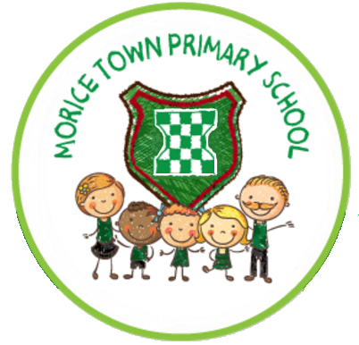

Place2Be is a children’s mental health charity and they are all about improving children’s mental health and behaviour in schools. The charity has over 25 years of experience working with pupils, families and school staff supporting children’s mental health and wellbeing.
Below is a link to Place2Be – Parenting Smart, offering practical tips and advice to support children’s wellbeing and behaviour.
A Place2Be survey found that around half (52%) of parents of 4-11-year-olds have felt isolated during the pandemic, and almost half (48%) of parents felt they would have benefitted from advice about how to manage their children's behaviour during the pandemic.
Place2Be developed Parenting Smart to help parents and carers support their children and manage their behaviour. It’s completely free to use and access.
Developed by Place2Be's parenting experts, the site is full of tips and advice on a range of topics including transition to secondary school, meltdowns, and sleep difficulties.
https://parentingsmart.place2be.org.uk/

It really is work taking a look!
