Writing Activities 3

1. Story time
Go back to https://www.youtube.com/watch?v=58kla7Ghxas .
Re-listen to Voices in the Park.

2. The progressive past tense
Read the information on Past Tense 2: progressive form.
- Use what you have learned to complete the exercises on the use of the Progressive form of the past tense.

3. Writing an email
Think about what Charles and Smudge might have done when they got home from the park.
Read the instructions on An Email from Charles or Smudge.
- Use the email template to write out your message.
- Check your work carefully: did you use examples of the progressive form of the past tense in your writing?
- Write an email reply back to your character from either Charles or Smudge.

4. Your park
- What does your park or playground or rec area have in it?
Draw a picture of your park on My Park and write about what sort of things you like doing there with your friends and family.

Past Tense 2: progressive form

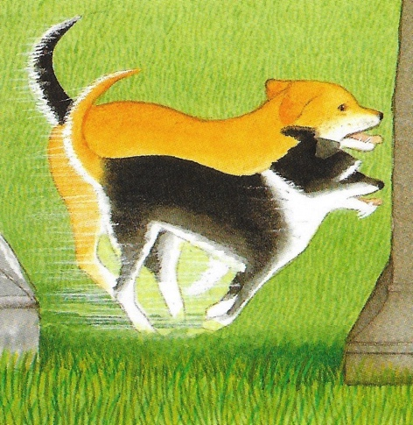

Past tense verbs can be in the progressive or continuous form.

Albert was finding his ball.

Victoria was running down the path.

Smudge and I were playing in the park.

Our parents were sitting on the bench.

These are in the past tense, but describe something that carried on happening, something that lasted for a while.
Victoria was running. - so Victoria carried on running …
We were playing. - so we kept on playing for a while…

Often the progressive form is used to show that something is continuing whilst another event occurs.

I was looking (progressive) for Charles but his mum pushed me out.

The dogs were sniffing (progressive) in the grass when the park keeper appeared. (simple)

Verbs in the progressive past are created by writing was (singular) or were (plural) + a verb ending in -ing.

He was playing We were laughing They were running away!

Using the Progressive Past

1. These verbs are in the simple form of the past tense. Rewrite them in the progressive form. Use either was or were with your verb.

sat ________________________________ jumped ___________________________ ran __________________________
barked _____________________________ talked ____________________________ felt ___________________________

2. These sentences begin with clauses in the progressive form. Add a clause in the simple past to finish the sentence.

Smudge’s Dad was reading his newspaper when ____________________________________________________________
Charles and Smudge were calling for the dogs but __________________________________________________________
The park was closing for the night but ____________________________________________________________________

3. Begin these sentences with a clause in the progressive form of past tense.

__________________________________________________________________when his Mum looked up in amazement.
_______________________________________________________________________but Albert had already gone home.
_____________________________________________________________________ when Smudge rang up on the phone.

On a piece of paper, write your own sentences for each of these verbs using the progressive form of the past tense:
to slide to search to walk to sigh

An Email from Charles or Smudge

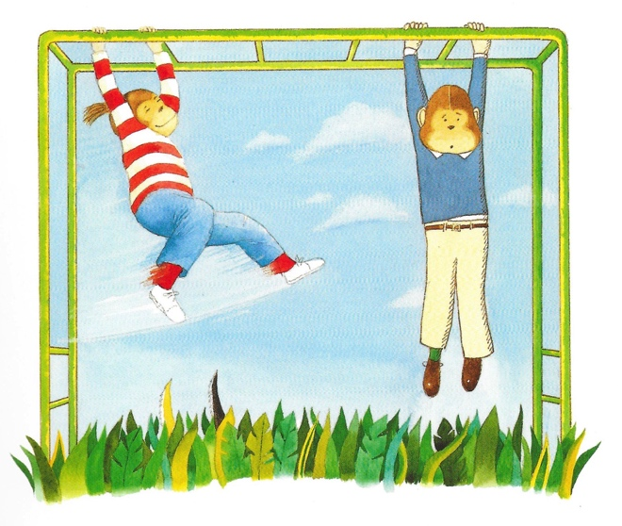

Charles and Smudge have arranged to email each other at the end of the day and say what they have been doing since they got home from the park.

- Decide whether you are going to be Smudge or Charles.
- Think about the three or four things that you did after getting home from the park and that you want to tell your new friend about.
- Use the email template to write your message to your friend.
- Because your email is a recount of what you have already done, write your message in the past tense.
- Make sure you use examples of the progressive from of the past tense in your writing – was waiting, were laughing, etc.
- Use your best handwriting for your email.
- Read your work through carefully at the end to check for spelling mistakes and errors over verb tense.

VoicesMail.com

To:

Subject:

From:

Message:

My Park

_________________________________________________________________________________________________________________________________________________________________________________________________________________________________________________________________________________________________________________________________________________________________________________________________________________________________________________________

