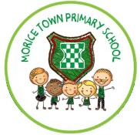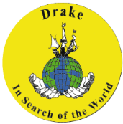

**Geography skills:**

Entry point – Jigsaw of UK.

Map reading – local area.

Use of Atlas for the UK.

Name the four countries of UK.

Locate countries of the UK.

Identify characteristics of the UK.

**Class readers:**

George’s marvellous medicine by Roald Dahl

Flat Stanley by Jeff Brown

**Art/DT skills:**

Develop art techniques in using colour, pattern, texture, line, shape, form and space.

Use basic principles of a healthy varied diet.

Develop collaging technique.

**Enrichment opportunities**

Send stories to Drake Year 2

First aid course

**ICT skills:**

Use algorithms.

Create and debug simple programs.

Predict the behaviour of simple programs.

Researching skills.

**Visible Learning:**

Pre and post assessment

Success criteria and WAGOLLS

**History Skills:**

Develop an awareness of the lives of significant individuals in the past.

Compare nursing past and present.

**Year 2**

**Brilliant Britain**

**Outcomes:**

1. Class vote – journey.
2. Sharing stories of journey.
3. Fact files about UK.
4. Letters to nurses.
5. Poster on how to stay healthy.
6. Administer first aid to a person.

**Purpose/Audience:**

1. Democracy Year 2.
2. Share stories with Drake Y2 children.
3. Share knowledge with Drake Y2 children
4. Thanking nurses.
5. Share with Foundation.
6. Life skills for family.