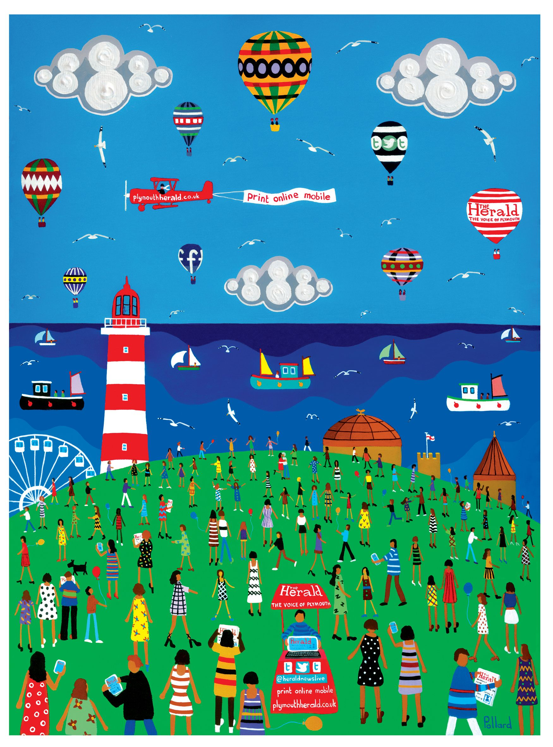

PE We will complete REAL PE Unit 5, which focuses on throwing and catching as well as reaction and response. We’ll be playing games such as basketball to support this.

RE

In RE we will be learning about how different religions celebrate different occasions and why these are important.

Art

This term we will be considering art that is local to Plymouth. Brian Pollard (local artist) will be visiting us as well as entering artwork into a local competition.

Music

This term we will be looking at different ways instruments produce sound and to play un-tuned instruments rhythmically.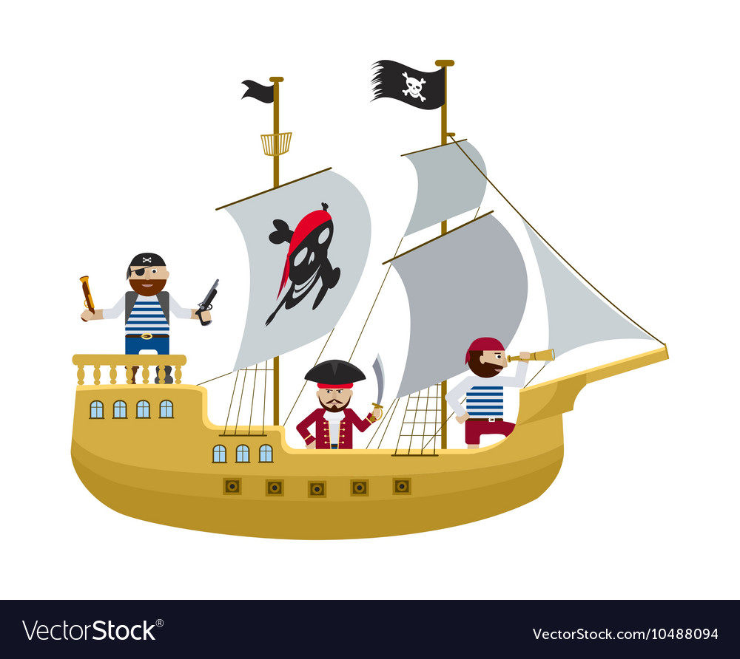

Science

This term the children will be learning about plants and living things and their habitats. This will link with our trip to the Aquarium and all the different animals we will come across.

Year 2 Info:

Staff:

Miss Everitt – Class Teacher

Mrs Penney – Full Time TA

Mr Twynam – PPA Thursday morning.

PE Days: Monday and Wednesday

Topics this year will include:

Autumn Term: Go Wild! And Let it Snow.

Spring Term: Once Upon a Time.

Summer Term: Ship Ahoy!

Theme

Our theme this term is Ship Ahoy! This will give the children the opportunity to explore water and pirate themed topics within school and on our school trip. They will learn about local history involving Sir Francis Drake and will consider seaside geography.

English

This term we will be learning how to write non-chronological reports and information texts. We will do this through our trip to the Aquarium and the Hoe.

Maths In maths, the children will be learning about time and measurement. We will also be getting ready for SATs by thinking about problem solving and techniques.

ICT

This term we will be learning about artists and making our own artwork on 2Paint.

**WELCOME TO YEAR 2**