To support your child with their learning, we have suggested a range of learning activities and experiences that may interest and hopefully inspire your child. We have included how we would like your child to share this learning, with either parents, teachers, classmates, the whole school or the wider community.

Colour in the jigsaw pieces if you have done a piece of Home Learning – it may be worth Dojos!
Build or design your own castle that would be fit for a king or queen.

Could you paint yourself as a king or queen? Think about what they look like in their portraits. Research online to look for pictures.
To link with our science this term could you explore the different matierals you use around the house. Does your family recycle? Could you make a list of all the recycling you do within a week?
Make a model out of recycled material. Your model could be of anything you want. You could link this piece of homework with making a castle too!
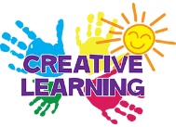
Weekly
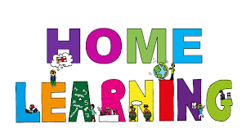
We expect every child to:
- Read at least 3 times each week and for parents to sign homework diaries to say this has been completed.
- Visit www.mathletics.co.uk at least once each week to practice their maths skills.
- Talk to their parents about something they have learned this week at school and what they have really enjoyed.
Parents may also wish to:
- Practice reading and spelling words from the appropriate aged spelling lists on the school website (http://www.moricetownprimary.co.uk/parents/reading-and-phonics)
- Practice handwriting using the school’s handwriting guidance.
Themed Learning
Write your own fairy tale story. As long or as short as you like!
Watch and learn the story of Rumplestiltskin and Princess and the Pea using youtube or books you have at home.

Borrow some traditional tales from the library and use these for bedtime reading.
Could you write a fact file about one of the famous kings or queens that we’re learning about in school?

