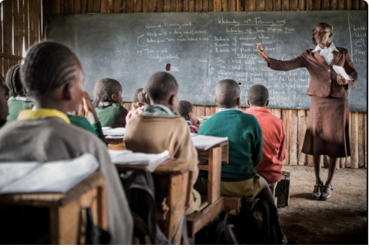

Schools Around The World

Story starter!
Could you write a letter to a school in another part of the world?
Think about the information you could include in the letter about your school, and what questions you could ask children in the school you’re sending the letter to.

Question time!
Where in the world could this photograph have been taken?
How might this school be similar/different to your school?
How might the lives of the children at this school be similar/different to yours?
What would you say to one of these children if you met them?

Perfect picture!
Can you draw a picture of what you think the perfect classroom or school would look like?

Sentence challenge!
Look carefully at the activity the teacher is asking her class to do.
Imagine you are in this teacher’s classroom. Can you write a sentence using some of the ideas she has given the class?

