Writing Activities 1

1. Story time
Go to https://www.youtube.com/watch?v=h7ypmw-0JU0 .
Listen to Ruth reading The Night Shimmy by Gwen Strauss and Anthony Browne.

2. Answering questions
Look at the Questions about The Night Shimmy.
- Read each question carefully.
- Listen again to parts of the story if you need to.
- Write your answers in the spaces provided.
- Check that your answers say what you wanted them to.

3. Writing about pictures
Read information on Expanded Noun Phrases. Make sure you understand it.
- Pause The Night Shimmy at a picture you really like or choose one from Pictures from The Night Shimmy.
- On My Favourite Picture, write about what is going on in the picture.
- Use expanded noun phrases for description.

- The Night Shimmy chooses the ‘best stories’ for Eric at night. What do you think the very best story is? Use The best story I know is... to record your suggestion.

Questions about The Night Shimmy

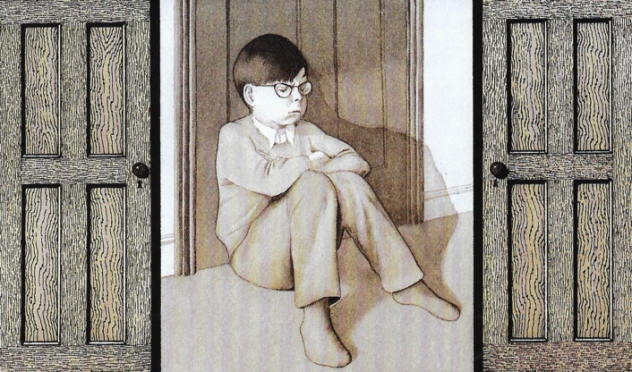

1. Who do you think the Night Shimmy is? Tick one of the options below or add your own answer.

A real friend of Eric’s _____________________________________________
A visiting wizard ________________________________________________
A superhero like Batman or Superman _________________________________
Eric himself imagining that he is the Night Shimmy ________________________
An imaginary friend of Eric’s ________________________________________

2. Explain why you think that.

______________________________________________________________________________________________________________________________________________

3. What sort of things does the Night Shimmy do for Eric? Mention at least three things.

_____________________________________________________________________________________________________________________________________________________________________________________________________________________

4. Why do you think the Night Shimmy disappears at the end of the story?

______________________________________________________________________________________________________________________________________________
_______________________________________________________________________

5. When does the parrot first appear in the story?

_______________________________________________________________________

6. When does it become real?

_______________________________________________________________________

7. How many parrots are there on the page which begins, ‘They began to talk.’?

_______________________________________________________________________

8. What do you think the parrot suggests about how Eric is feeling at the end of the story?

______________________________________________________________________

9. Look at the page, ‘Eric slammed his bedroom door shut...’ Why do you think Anthony Browne has drawn the picture just in greys and browns?

______________________________________________________________________________________________________________________________________________

10. With most of the pictures in the book, it is a bit like we are looking through a window that is surrounded by black. How are the last three pages different?

_______________________________________________________________________

11. Why do you think are they different?

_____________________________________________________________________________________________________________________________________________________________________________________________________________________

Expanded Noun Phrases

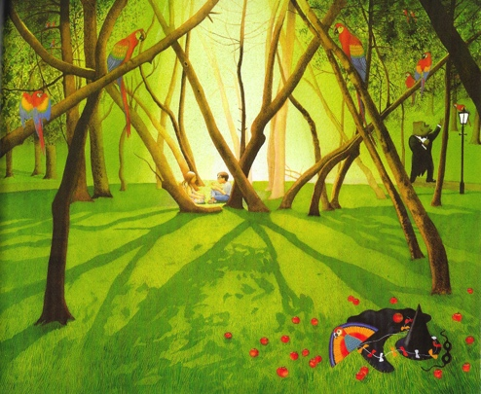

These are examples of noun phrases.

the park a kite some trees two children

If we want to describe the nouns (the objects or things or people) in these phrases in more detail we can expand the phrases.

We do it like this:

1. Add some adjectives to tell us more about the noun.

the big park a bright, cheerful kite some tall, thin trees two happy children

If we use two adjectives we usually separate them with a comma.

2. Modify the adjective with adverbs. The adverbs tell you more about the adjectives.

the really big park a very bright, cheerful kite some extremely tall, thin trees two rather happy children

3. Add a prepositional phrase. The prepositional phrase tells you a bit more about where or when things happen or how things relate to one another.

the really big park with a singing gorilla
a very bright, cheerful kite beside the path
some extremely tall, thin trees on top of the hill
two rather happy children before bedtime

Pictures from The Night Shimmy

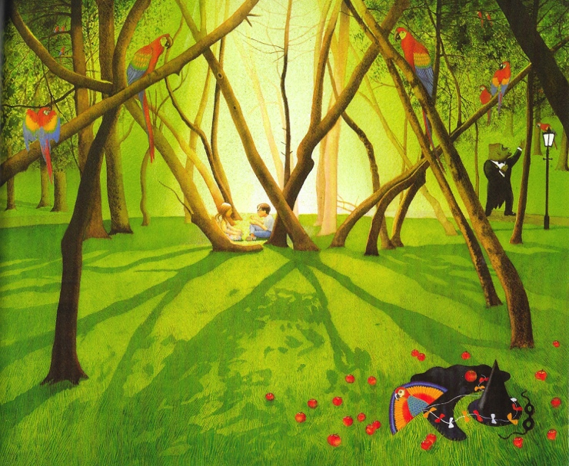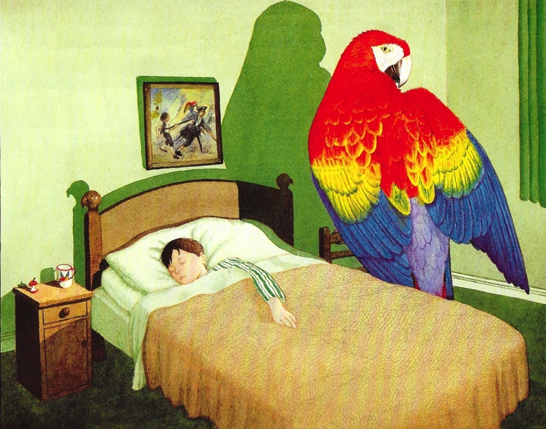

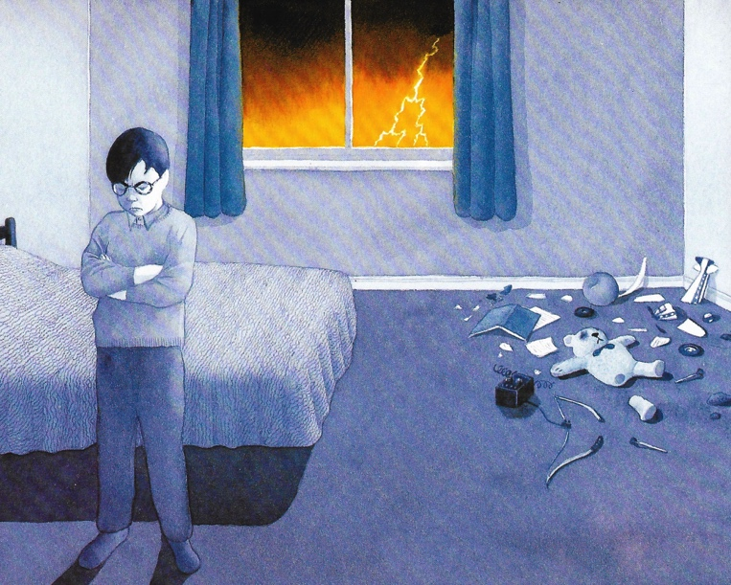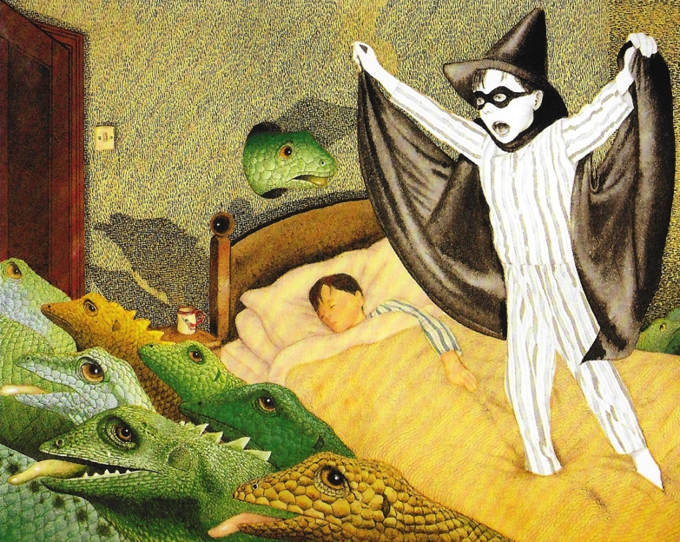

My Favourite Picture

The best story I know is...

Name of story:
Author or illustrator (if known):
What happens in the story:
The kind of people I think would the like the story:

