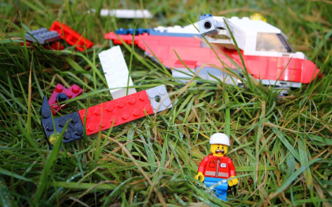

Lawrence was injured, afraid, lost and completely alone. He had been thrown viciously from the aircraft after the flock of birds had attacked the propellers.
As he laid there, listening to his racing heart, he wondered what would happen to him, when all of a sudden…

Please write the beginning of this story into your book in your neatest writing and then continue it, trying to write two paragraphs (remember to use the 5Ws – Who? What? When? Where? Why?)

