Back to school
We are really looking forward to having you back at Morice Town Primary Academy – we have really missed you.
You are going to be in Year 1 Bubble A
- Your teacher is going to be Miss Rood

- She will be wearing a mask when she comes to meet you and will be standing 2m away behind a line. Miss Rood will look like this in class, but she will look like this when you see her in the morning and at the end of the day. You might see other teachers wearing a mask too.
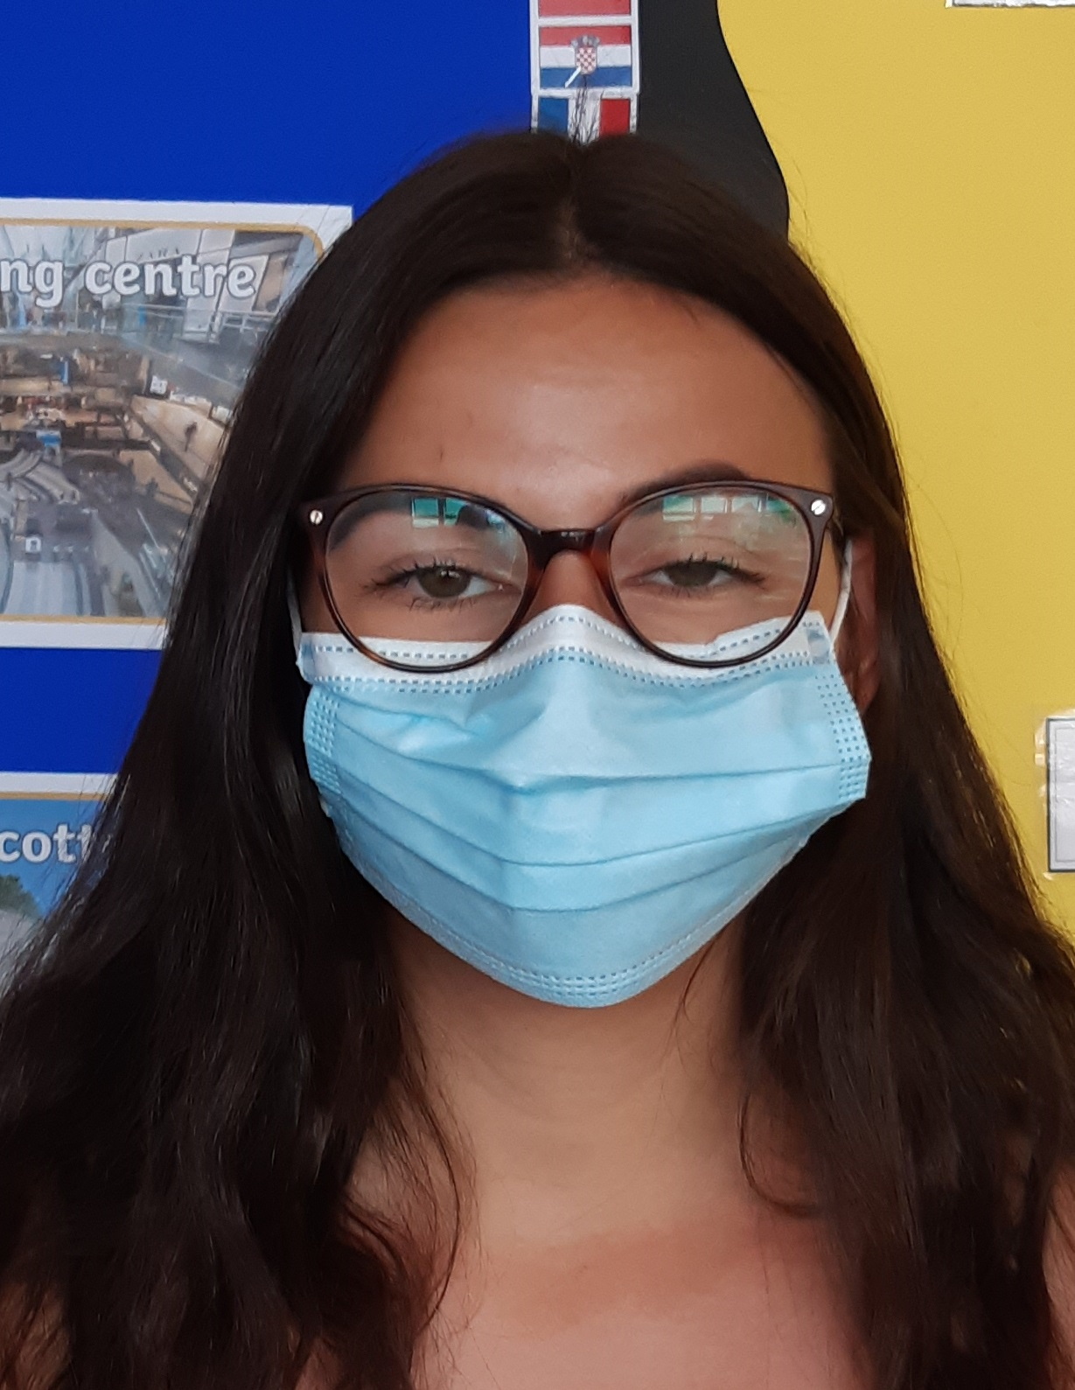
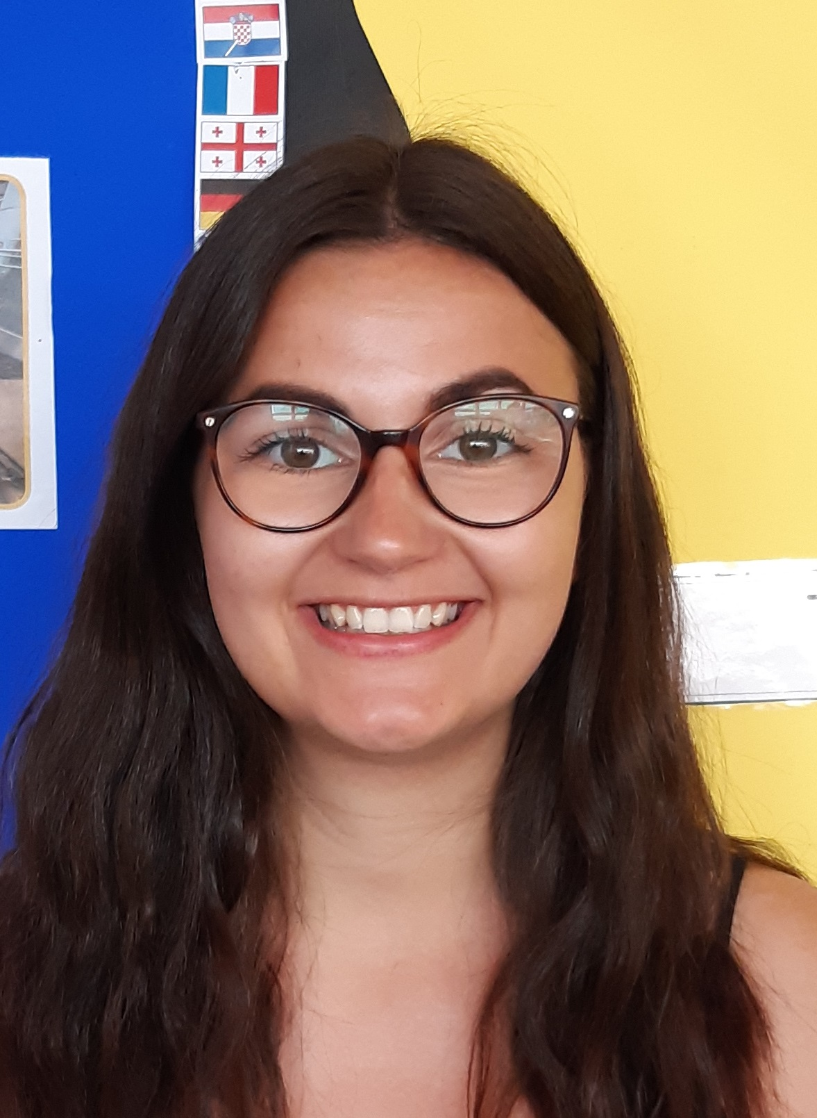

The Teaching Assistants will be Mrs Lewis

You will be in the Year 3 classroom. It looks a bit different. Can you see the black and yellow tape on the floor?
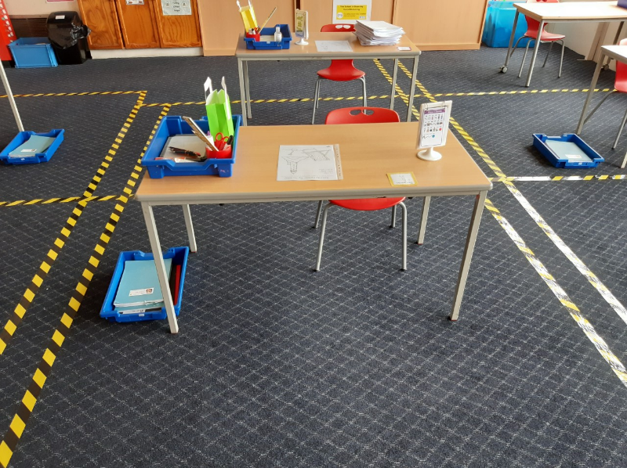
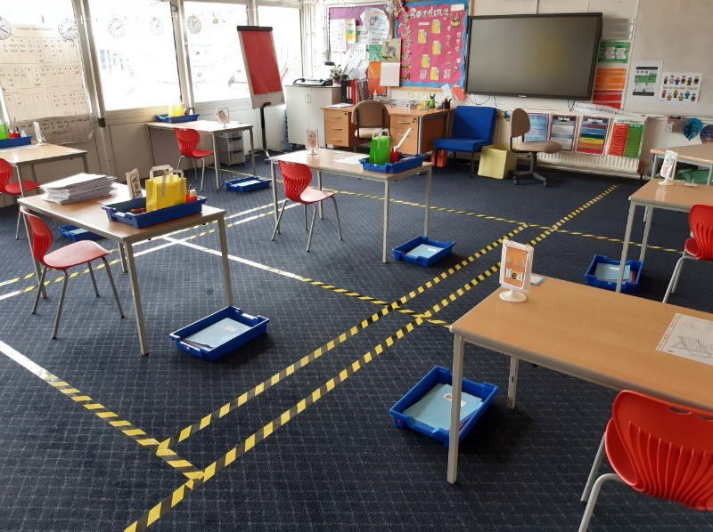

You will see black and yellow tape on the floor in other places too.

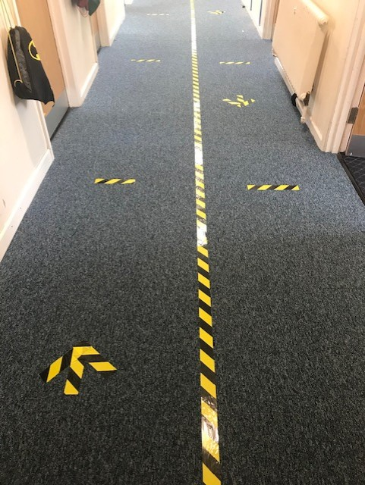
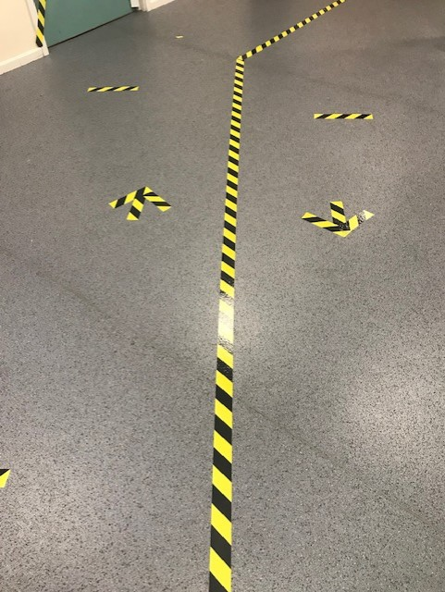

In the morning, Mrs Donnellon will be waiting for you at the gate. She will be wearing a mask.
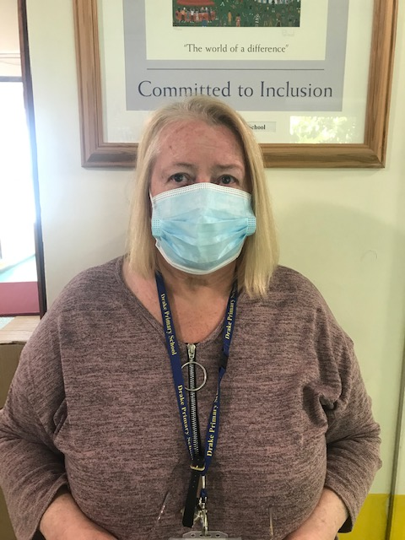

Follow the arrows on the playground and then you will need to wait on the dots. The dots are 2 metres apart.
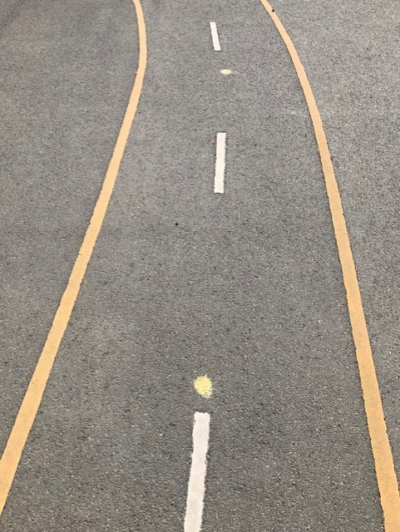
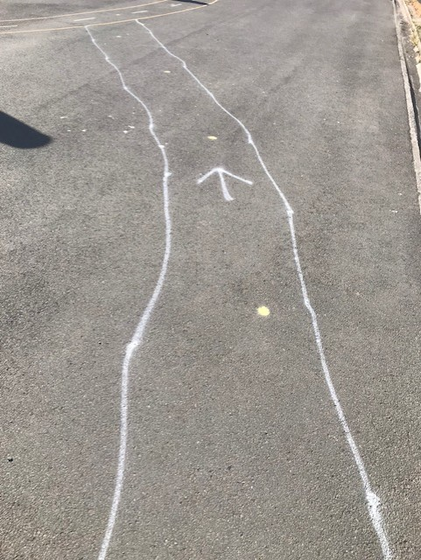

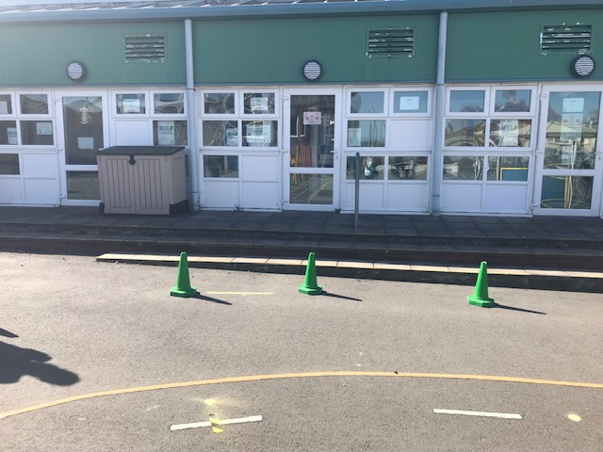
Can you see the black and yellow tape on the floor? When you reach the tape, your teacher will be waiting for you by the green cones each morning.

