**Possible scenes to write about:**

**Become a Writer!**

Write a short narrative based on a scene from Holes**.**

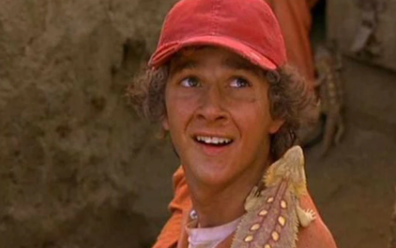

* Arriving at Camp Green Lake
* Finding treasure while digging a hole
* Making his escape from Camp Green Lake
* In the hole while surrounded by yellow spotted lizards.

**Plan:** draw a story map. Sequence each part of the scene and add key vocabulary.

**Draft:** draft each paragraph of your scene. Remember to include a range of grammar and punctuation that will engage the reader.

**Edit:** use the narrative success criteria to proof read and edit your writing.

**Neat:** with your best handwriting write up your drafted narrative into your workbook that was provided.

IALT: write a short narrative based on the story of Holes.

**Writing Toolkit:**  
Use a range of punctuation correctly, including: ; : " " apostrophes,

Use verb tenses consistently and correctly throughout their writing,

Use a variety of clauses and phrases to up-level sentences,

Spell all Year 3 and 4 words correctly; spell most Year 5 and 6 words correctly,  
  
Use joined handwriting that is legible,

Use ambitious vocabulary (identify three in your writing).

|  |  |  |
| --- | --- | --- |
| **Learner** | **Success Criteria**  Short Narrative - Holes | **Teacher** |
|  | Ambitious vocabulary. |  |
|  | Figurative language to create vivid imagery. |  |
|  | Variety of punctuation. |  |
|  | Short sentences for impact. |  |
|  | Check the toolkit |  |

**Extended writing ideas:**

**Formal letter to the warden: See WAGOLL below**

Dear Warden,

I think the conditions at Camp Green Lake are too harsh, and it should be improved. If you want your workers to dig hard, they’ll need a good condition to live in.

Camp Green Lake is unhygienic and that needs to change. I think that instead of having 4 minutes of shower time, we should have at least 6minutes so they could have enough time to get clean and have an opportunity to use the soap. After a long day in the scorching sun, they would sweat a lot, and they would get dirty digging, so they should get a nice shower to remove all those terrible odours, suds and bacteria or germs. Just think, any worker would need a day off because they didn’t have a proper shower from all those germs.

The food in Camp Green Lake is too low quality. For example, once you serve brown stewed meat and vegetable wasn’t green! Don’t you think that the workers should get something as a reward for digging for a long day of work? After all, they still need energy to continue. Would you like to eat something disgusting just to get the energy?

Everyone knows that a good night’s sleep leads to an energized day. Think. How can you possibly sleep in a tiny cot that smells like sour milk? After a long day of digging and working, the workers should have a comfortable sleep so they would feel more energized for the next day, which means that the workers will have the energy to dig multiple holes the next day. Doesn’t that sound like a great idea? So I think that you should pay for better beds that get washed in while and a dorm for each of the boys. It’s worth it!

Overall, I hope that you would take my advice. If you do, I promise there would be more holes than ever! Don’t you want that?

Sincerely, Stanley

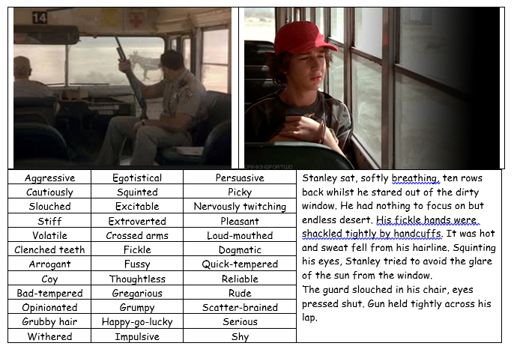**Character description:**

|  |  |
| --- | --- |
| **Physique**  gangling; gaunt; haggard; lanky; scrawny; skinny; spindly; withered / agile; athletic; lean; lithe; petite; rangy; reedlike; slender; slight; slim; thin; trim; willowy / barrel-chested; beefy; big-boned; brawny; buxom; chubby; fat; muscular; well-muscled; voluptuous; stocky  **Voice**  bass; bellowing; booming; breathy; cackling; childlike; croaking; crackling; drawling; droning; falsetto; faltering; feeble; flat; fluting; gravel; guttural; harsh; hoarse; hollow; husky; hypnotic; lilting; lisping; monotone; nasal; piercing; ponderous; purring; quavering; rasping; reedy; resonant; robust; sensuous; sharp; shrill; soothing; soporific; spluttering; squawking; squeaky; sultry; thick; thin; throaty; thunderous; tremulous; velvet; warbling; wheezing; whining;  **Facial** **Hair**  beard; bristles; five o'clock shadow; fuzz; goatee; moustache; muttonchops; sideburns; stubble; whiskers  **Hair condition**  disarrayed; disheveled; ill-kempt; knotted; messed up; messy; mussed up; mussy; uncombed; unkempt; ragged; ruffled; shaggy; tangled; tousled; twisted; untidy; matted / combed; kempt; neat; neatly combed; thick; thinning; tidy; / greasy; oily / dry; split-ended / flecked; grizzled; wiry; receding; unshorn  **Eye colour**  **Blue -** bright blue; dark blue; light blue; luminous blue; piercing blue; sky blue;  **Brown -** dark brown; light brown;  **Grey -** light grey; dark grey; deep grey; stone; stone grey; cobalt; slate grey;  **Green -** emerald; jade; light green; dark green; bright green; sea green; | **Skin Colour**  apricot; black; bronze; brown; caramel; cream; ebony; fair; ivory; lily-white; milky; nut-brown; olive; red; white; yellow;  **Complexion**  **Appearance -** blush; flush; freckled; glowing; jaundiced; mottled; pallid; pale; pasty; rosy; ruddy; russet; sallow; splotchy;  **Texture -** acned; cadaverous; craggy; greasy; leathery; peeling; pitted; pocked; scarred; sunburnt; wrinkled  **Hair colour**  **Black** - coal black; jet black; raven; sable; ebony; charcoal; ink-black; sooty;  **Dark Brown** - brunet/te (male/female - male form rarely used); auburn; chestnut; chestnut brown; walnut;  **Light Brown** - ash brown; mousey; chocolate; sandy; tawny; golden brown; nutmeg; nut brown; cinnamon;  MCj02381930000[1]**Lips -** blue; cracked; dry; fat; full; luscious; parched; parted; red; ruby; thin; wet  **Teeth -** buck; crooked; gap-toothed; gappy; gleaming; large; protruding; razor-like; small; sharp; shining; straight; white; yellow;  **Nose -** aquiline; beaky; broad; bulbous; button; button-like; curved; eagle-like; hatchet-like; hooked; prominent; straight; turned up;  **Arms** - long; thick; skinny; pudgy; strong; muscular  **Shoulders** - broad; ox-like; sloping; drooping; hunched; rounded;  **Hands -** elegant; long; long-fingered; rough; stubby; shovel-like; slender; spade-like  **Fingernails** - bitten; broken; claw-like; dirty; hooked; long; painted; sharp; talon-like;  **Facial**  bewildered; disbelieving; disgust; frown; puzzled; nonplussed; scowl; smile;  **Visual**  blank look; gaze; glance; glaring; glowering; hard stare; piercing; sideways glance; vague; vacuous; vacant; searching; empty; |