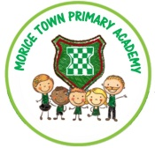

Drake and Morice Town Primary Academies Local Governing Body meeting dates 2021-22

Monday 27th September 2021

Monday 29th November 2021

Monday 24th January 2022

Monday 21st March 2022

Monday 9th May 2022

Monday 18th July 2022

Meetings are held alternatively between Drake Primary and Morice Town Primary both with a start time of 4pm

Page 1 of 1

