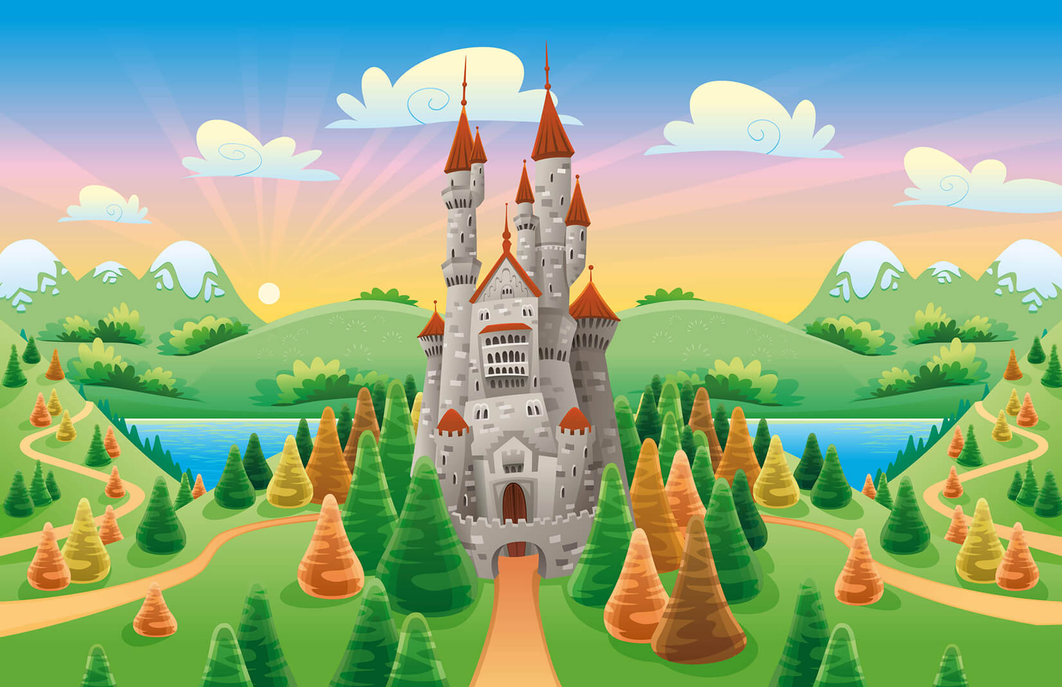

Year 2 Info:

Staff:

Miss Everitt – Class Teacher

Mrs Penney – Full Time TA

Mr Twynam – PPA Wednesday morning.

PE Days: Wednesday and Friday

Topics this year will include:

Autumn Term: Go Wild! And Let it Snow.

Spring Term: Once Upon a Time.

Summer Term: Ship Ahoy!

English

This term we will be learning how to recount stories through the book ‘Rumplestiltskin’ and creating our own newspaper article using the story of ‘The Princess and the Pea.’

Maths

In maths, the children will continue to learn about multiplication and division. They will also have the opportunity to explore statistics and the properties of shape.

ICT

This term we will be carrying out questionnaires and discussing effective searching.

Science

This term the children will be learning about everyday materials. They will particularly look at the importance of using the correct materials depending on their function. This will link to recycling and the importance of looking after our planet.

**WELCOME TO YEAR 2**

History

In History this term we will be learning about Kings and Queens and the importance of the Monarchy.

DT

This term we will be looking at healthy eating and the importance of fruit and veg in a balanced diet. We will explore eating different fruits and veg and make our own smoothies.

Theme

Our theme this term is Once Upon A Time. This will give the children the opportunity to explore all the traditional tales and be able to retell, as well as understand, how to write a story. We are hoping to organise a trip to the library for the children to hear some traditional tales as well.

RE

In RE we will be learning about different places of worship and how important it is to accept the beliefs of others.

PE

We will complete REAL PE Unit 3, which focuses on balance through a set of interactive stories.