1. 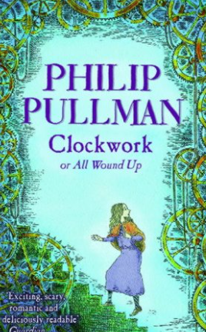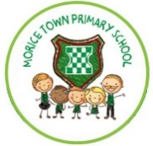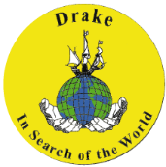

**Art/DT skills:** – use plastic bottle tops to create a mosaic style piece of art linked to plastic pollution.

- use plastic materials to form a sea creature under the ocean. This will symbolise the impact of plastic pollution on our oceans.

**Geography skills:  
What is a coast?**   
- Identity features of coastlines and those in our surrounding area.  
- Weathering and erosion

**Global warming:  
-** rising sea levels **-** ice glaciers melting  **-** ecological systems **-** climate change

**Save our oceans:  
-** plastic pollution  **-** fishing

**Purpose/Audience:**

1. To build on geographical knowledge and vocabulary.
2. To write using different formalities – to make children aware that they can contribute to helping the environment.
3. To share their environmental knowledge with younger children in the school. Help educate younger children about our changing world.
4. To share the views on plastic pollution through different perspectives.
5. Engage readers with appealing content and help support the environment.

**Outcomes:**

1. Label the features of a coastline using geographical vocabulary **(Geography).**
2. To write a persuasive letter to our local MP in regards to helping our coastlines **(written).**
3. Documentary voice over in the style of David Attenborough. Use a pre-recorded piece of footage and children will write a transcript **(ICT).**
4. To write two narrative poems – personify plastic pollution as a predator (sea creature perspective and plastic perspective- **written)**
5. Produce a persuasive advert/poster to save our oceans using Microsoft Word **(ICT)**

**ICT skills:**

**Documentary voice over** in the style of David Attenborough. Use a pre-recorded piece of footage and children will write a transcript.

Persuasive advert/poster to save our oceans **(word document)**

**Year 6**

**Our Changing Coasts**

**Class reader:**

**Visible Learning:**

Success criteria for extended writing and WAGOLLS.