IALT hunt for 2D shapes.
Shape: | Tally: | Number:
square
circle
rectangle
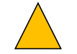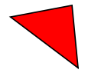triangle

