Questions about the Story
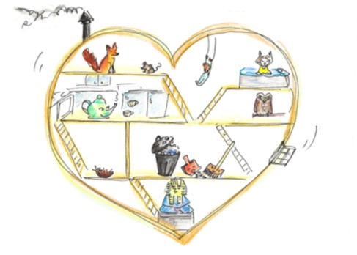
1. Find an example of traditional or ‘fairy tale’ language used in the story.

_____________________________________________________________________

2. Sequence these events from the story by putting 1st, 2nd, 3rd etc. before each event.

________ The Cat reassures the Dragon that he has told the story of the Little Story
who didn’t want to be told.

________ The Little Story feels ashamed, believing she is not a very good story.

________ The Cat is upset at being called fat!

________ The Mice visit the home of the Dragon.

________The Dragon tells the story of the Little Story to the old Crocodiles.

________The Little Story dances with joy at finally being told.

2. Find and copy the two sentences in the story that say that the Dragon was renowned and adored for being a good storyteller.
_______________________________________________________________________
_______________________________________________________________________

3. In your own words, explain why you think the Little Story does not want to be told.
____________________________________________________________________________________________________________________________________________________________________________________________________________________________________________________________________________________________

4. Which of the following words does not describe well the attitude of the Teapot in the Dragon’s heart towards the Little Story? Put a ring around your answer.

considerate thoughtless thoughtful caring gentle

5. Which of the following words best describes the attitude of the Fox in the Dragon’s heart towards the Little Story? Put a ring around your answer.

upset bored sneering angry surprised

6. Who do you think is more upset – the Dragon when he finds he can’t tell the story to the Mice, or the Little Story when she feels she is not good enough to be told?
______________________________________________________________________
_______________________________________________________________________

Why do you think that?
_____________________________________________________________________________________________________________________________________________________________________________________________________________________

7. How might the other stories in the Dragon’s heart have treated the Little Story after the Dragon had finally been able to tell her tale?
_____________________________________________________________________________________________________________________________________________________________________________________________________________________

8. Have you ever been worried you weren’t good enough to do something? What was that thing, and how did you feel about it?
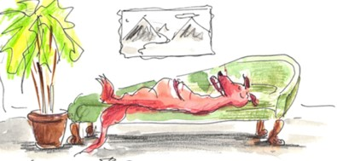
____________________________________________________________________________________________________________________________________________________________________________________________________________________________________________________________________________________

Questions about the story – Answers

1. Find an example of traditional or ‘fairy tale’ language used in the story.
Once upon a time…. One day …. Red-gold dragon…..

2. Sequence these events from the story by putting 1st, 2nd, 3rd etc. before each event.

4th The Cat reassures the Dragon that he has told the story of the Little Story
who didn’t want to be told.

2nd The Little Story feels ashamed, believing she is not a very good story.

3rd The Cat is upset at being called fat!

1st The Mice visit the home of the Dragon.

6th The Dragon tells the story of the Little Story to the old Crocodiles.

5th The Little Story dances with joy at finally being told.

2. Find and copy the two sentences in the story that say that the Dragon was renowned and adored for being a good storyteller.
He is famous. All the animals love his stories.

3. In your own words, explain why you think the Little Story does not want to be told.
She is scared that she is not actually a very good story. She doesn’t feel she is as big and as good a story as the other stories around him.

4. Which of the following words does not describe well the attitude of the Teapot in the Dragon’s heart towards the Little Story? Put a ring around your answer.

considerate thoughtless thoughtful caring gentle

5. Which of the following words best describes the attitude of the Fox in the Dragon’s heart towards the Little Story? Put a ring around your answer.

upset bored sneering angry surprised

6. Who do you think is more upset – the Dragon when he finds he can’t tell the story to the Mice, or the Little Story when she feels she is not good enough to be told?
Why do you think that?
Accept any answer that has a good reason – for example:

The dragon because he feels like his reputation for being a great storyteller is being ruined.

The little story because she feels scared and humiliated.

7. How might the other stories in the Dragon’s heart have treated the Little Story after the Dragon had finally been able to tell her tale?
Accept any answer that has a good reason – for example:

The fox or the walrus might have had to apologise and admit they were wrong.
The teapot might have said something nice, like, “I knew it would be fine when you were told.”

