To support your child with their learning, we have suggested a range of learning activities and experiences that may interest and hopefully inspire your child. We have included how we would like your child to share this learning, either with parents, teachers, class mates, the whole school or the wider community.

Colour in the jigsaw pieces if you have done a piece of Home Learning – it may be worth Dojos!
Themed Learning
Write a fact file about the history of animation.

Write a quest story linked to an animation film.
- Moana
- How to Train your Dragon
Write a letter to your favourite animation character.
Retell the story of your favourite animation film.
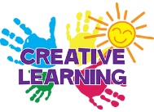
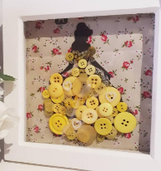
Make your own button art of an animation character.
Sketch your favourite animation characters.
Bake your own Disney themed cookies.
Design your own watercolour painting.

Weekly
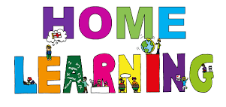
We expect every child to:
- Read at least 3 times each week and for parents to sign the reading/homework diary to say this has been completed.
- Visit www.mathletics.co.uk at least once each week to practise their maths skills.
- Talk to their parents about something they have learned this week at school and what they have really enjoyed.
Parents may also wish to:
- Practise reading and spelling words from the appropriate aged spelling lists on the school website (http://www.moricetownprimary.co.uk/parents/reading-and-phonics)
- Practise handwriting using the school’s handwriting guidance.
- Practise times tables 3 times a week.

