Easter Egg Hunt Activity

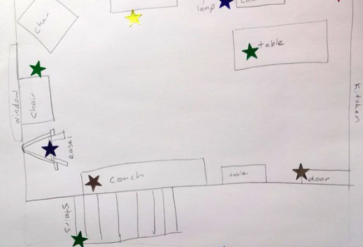
Survey your house and decide on an Easter egg trail! Don’t worry if you don’t have any eggs, you can use anything that you like for this. Then please design your map (straight in your books) showing us exactly how you laid your hunt out – Let us know who found the most!

