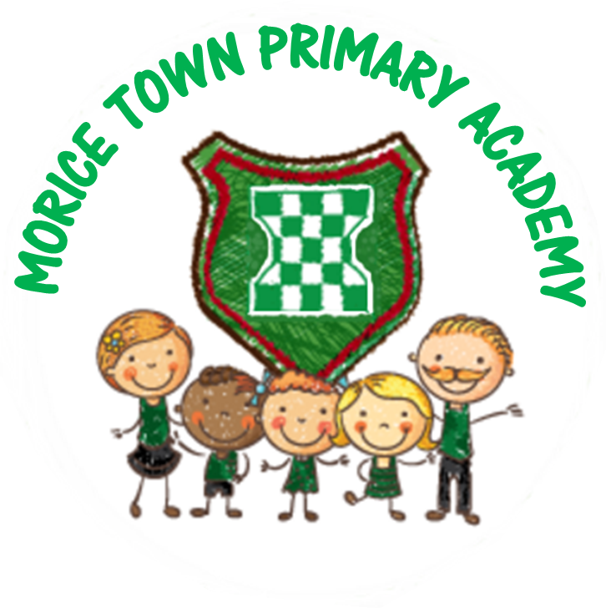

Drake & Morice Town Primary Academies Knowledge & Skill Organiser: Superhero Me & Autumn Date: 09.09.2019-17.10.2019
 | Key Learning Outcomes | Activities
PSED | • I can understand that my own actions affect other people.  • I can understand how to follow school rules and why it is important.  • I can understand how to share with my friends.  Early Learning Goal  Children talk about how they and others show feelings, talk about their own and others’ behaviour, and its consequences, and know that some behaviour is unacceptable. They work as part of a group or class, and understand and follow the rules. They adjust their behaviour to different situations, and take changes of routine in their stride. | Learning rules and routines of Foundation when settling into the new classroom.  Class dojos, stickers, ROARR award.  Introduce ROARR characters during Busy Time.  Reward positive play, good listening, tidying etc  Use songs for routines to help children understand rules for Foundation and working as a team.  Use circle time to talk about our likes, dislikes and who we live with at home, what do we want to be when we grow up and why? What makes us special? (superpowers)  Talk about how we have changed since we were born.  How to look after class bear when he goes on his adventures to different places.  What do we need to grow up and be healthy? Introduce snacks, lunchtimes.  Class target linked to sharing with friends in different areas of the provision such as home corner, construction workshop and when using the bikes.  Children to understand rules of playing with the older children at lunchtimes.  Photos of school linked to settling into a new environment.
CAL | • I can concentrate on an activity.  • I can listen and play at the same time.  Early Learning Goal  Children listen attentively in a range of situations. They listen to stories, accurately anticipating key events and respond to what they hear with relevant comments, questions or actions. They give their attention to what others say and respond appropriately, while engaged in another activity. | Home corner role play area linked to who I live with and the people in my family.  Listen to stories together during story time.  Reading area with different books to share with friends, books around the provision linked to Superhero and Autumn.  Leader to talk about time with class bear and questions from friends about his adventure.  Bears and puppets in role play area to encourage talk and storytelling.  Adults encourage talk during Busy Time.  Talk buddies on the carpet.  Small world with mini me puppets of the children dressed up as who they want to be when they grow up.  After looking at pictures of autumn and going on a walk, discuss as a class/ small group/ individual. Act as a scribe for the children so that they can describe what Autumn means to them.  Discuss signs of Autumn. Read stories such as the Gigantic Turnip, Stone Soup, Little Red Hen etc Listening for sounds and talking about seasons.  Sing songs linked to Harvest and Autumn. Books linked to settling into school, being a kind friend etc.  Scribing stories for children.  Circle time games as a class or small group.  Speech & Language intervention to support all children.  Blank Level baseline to support children’s understanding.
PD | • I can use tools and materials safely and with increasing control.  • I can use a preferred hand to carry out different activities.  • I can start to retrace patterns when drawing.  • I can form recognisable letters.  • I can hold a pencil properly.  - I can use the toilet independently.  Early Learning Goal  Children show good control and co-ordination in large and small movements. They handle equipment and tools effectively, including pencils for writing. | Funky Finger activities throughout the provision such as threading beads for patterns/ peg boards / cogs and laces / large chalks / play dough etc.  Use Paint & Create to making models when using tape, scissors, glue and experimenting different joining techniques.  Self-resource own paint from pump bottles.  Dough Gym/Squiggle As You Wiggle – daily sessions (dancing, shaving foam, large crayons for mark making to music/name writing.)  Chopping up fruit for snack and vegetables for cooking tasks (soup making).  Exploring bikes and trikes.  Obstacle courses to develop gross motor skills linked to the climbing frame.  What do we need to grow up and be a healthy adult?  Try different foods during snack that we haven’t tried before/lunchtime.
Literacy | • I can give meaning to marks.  • I can hear and say the initial sound in words.  • I can segment the sounds in simple words and blend them together.  • I can link sounds to letters, naming and sounding the letters of the alphabet.  • I can use some clearly identifiable letters to communicate meaning.  • I can write my own name and other things such as labels, captions and sentences.  • I can write short sentences in meaningful contexts.  Early Learning Goal  Children use their phonic knowledge to write words in ways which match their spoken sounds. They also write some irregular common words. They write simple sentences which can be read by themselves and others. Some words are spelt correctly and others are phonetically plausible. | Draw a picture of what I enjoy doing at school and begin to write about it.  Draw a picture of what I want to be when I grow up and begin to write about it.  Write/draw signs of Autumn.  Write letters to characters in stories.  Read a variety of stories which link to our topic.  Provide writing resources in each area, clip boards, rolls of paper, chunky pens etc.  Role play which encourages mark making.  Books in each area of the provision linked to the topic.  Use name cards to support recognition and writing.  Daily phonic lessons.  Daily English sessions.
M aths | • I can use words such as ‘more’ and ‘fewer’ to compare two sets of objects.  • I can find the total number of items in two groups by counting all of them.  • I can find the number that is one more than a given number.  • I can record using marks and talk about it.  • I can identify mathematical problems based on own interests.  Early Learning Goal Children count reliably with numbers from 1 to 20, place them in order and say which number is one more or one less than a given number. | Introduce a number a day/week through guided inputs (1-10).  Pegging numbers on a washing line in order.  Working with number lines.  Use unifix to make towers.  Water set up linked to filling/emptying, compare bears to order height and weight.  Use charts to find favourite foods, colours etc to find out more about friends.  Counting bricks, pencils, anything in the environment.  Fishing for numbers up to 10.  Attempt to write as well as recognise and order numbers.  Use songs such as 10 green bottles.
EAD | • I can create simple representations of events, people and objects.  • I can choose particular colours to use for a purpose.  • I can introduce a storyline or narrative into my play.  • I can play alongside other children.  Early Learning Goal  Children use what they have learnt about media and materials in original ways, thinking about uses and purposes. They represent their own ideas, thoughts and feelings through design and technology, art, music, dance, role play and stories. | Make models in the Paint & Create linked to houses/buildings from the local area and interests exploring joining techniques such as gluing, tape, use of hole punchers and string.  Create a self-portrait using local artist Sir Joshua Reynolds.  Healthy eating snacks /food for celebrations harvest. Print with vegetables.  Make observational drawings in pastels of leaves, veg, conkers, acorns etc. leaf rubbing and printing.  Paint station with poster paint and brushes primary colours. Introduce different brushes to make textures. Encourage colour mixing using pumps/ squeeze bottles. Introduce powder paint in sugar shakers. Show how to make a wash.  Musical instruments used in role play.  Engage in musical sessions.
UW | •Shows interest in the lives of people who are familiar to them.  •Remembers and talks about significant events in their own experience.  •Recognises and describes special times or events for family or friends.  •Shows interest in different occupations and ways of life.  •Knows some of the things that make them unique, and can talk about some of the similarities and differences in relation to friends or family.  •Enjoys joining in with family customs and routines.  Early Learning Goal  Children talk about past and present events in their own lives and in the lives of family members. They know that other children don’t always enjoy the same things, and are sensitive to this. They know about similarities and differences between themselves and others, and among families, communities and traditions. | During circle time activities talk about who we live with and talk about families and how they compare.  Talk about how we have changed from a baby and how we will continue to grow into an adult.  Discuss what we would like to be when we grow up. Possible visit from fireman/policeman etc.  Make a collection of Autumnal objects and share with class. Discuss changes in seasons. Make soup using vegetables.  Autumn walk, collect leaves and discus how they have changed since the summer. Compare texture, feel etc.  Photographs of school to find different areas of the environment.  Photographs of family on display and discussions with children around this.  Search our local area on google earth.  Use Beebots to follow instructions on a map.  Discuss emergency numbers and how to stay safe.  Experience the use of electrical equipment linked to snack.  Walk around the local area.

