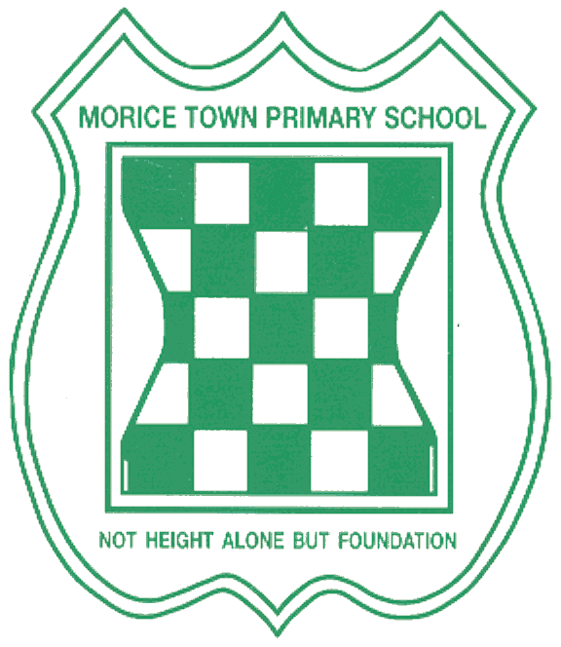

Drake and Morice Town Primary Academies Local Governing Body Meetings 2019-2020

• Monday 23rd September 2019
• Monday 11th November 2019
• Monday 20th January 2020
• Monday 16th March 2020
• Monday 4th May 2020
• Monday 22nd June 2020

All governors meeting start at 4pm.

