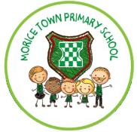

**Class reader:**

How to train a dragon by Cressida Cowell

**ICT skills:**

Log on independently.

Explore inputs to computers.

Communicate using a blog.

**Visible Learning:**

Pre and post assessment

Success criteria

**Art/DT skills:**

Create different tones of colour.

Observe and recreate images of the GFOL.

Design and build houses.

Y2 Fire, Fire!

**History Skills:**

Recognise historical events.

Explore historical events.

Comparing houses.

Ordering and sequencing events.

Use sources.

**Geography skills:**

Locating London.

Observing images.

Map skills.

Describe and compare locations.

**Outcomes:**

1. Write Thomas Farriner’s Diary.
2. Instructions for making bread.
3. Explanation of recycling.
4. Descriptions of London now and 1666.
5. Build houses to burn.
6. Create post GFOL picture using charcoal.

**Purpose/Audience:**

1. Year 2 time capsule.
2. Make bread for friends.
3. Share knowledge with Energy for Waste staff.
4. Display.
5. Share learning with parents.
6. Mini gallery for Year 5.