Tuesday 7th July
IALT make predictions.
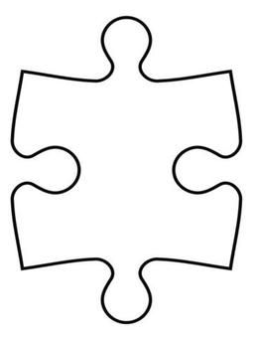
Write your prediction about what Stan will do about Lancelot in the centre puzzle piece. Write clues that prove your prediction right in the other puzzle pieces.
I predict that…
My prediction was correct. My prediction was incorrect.

