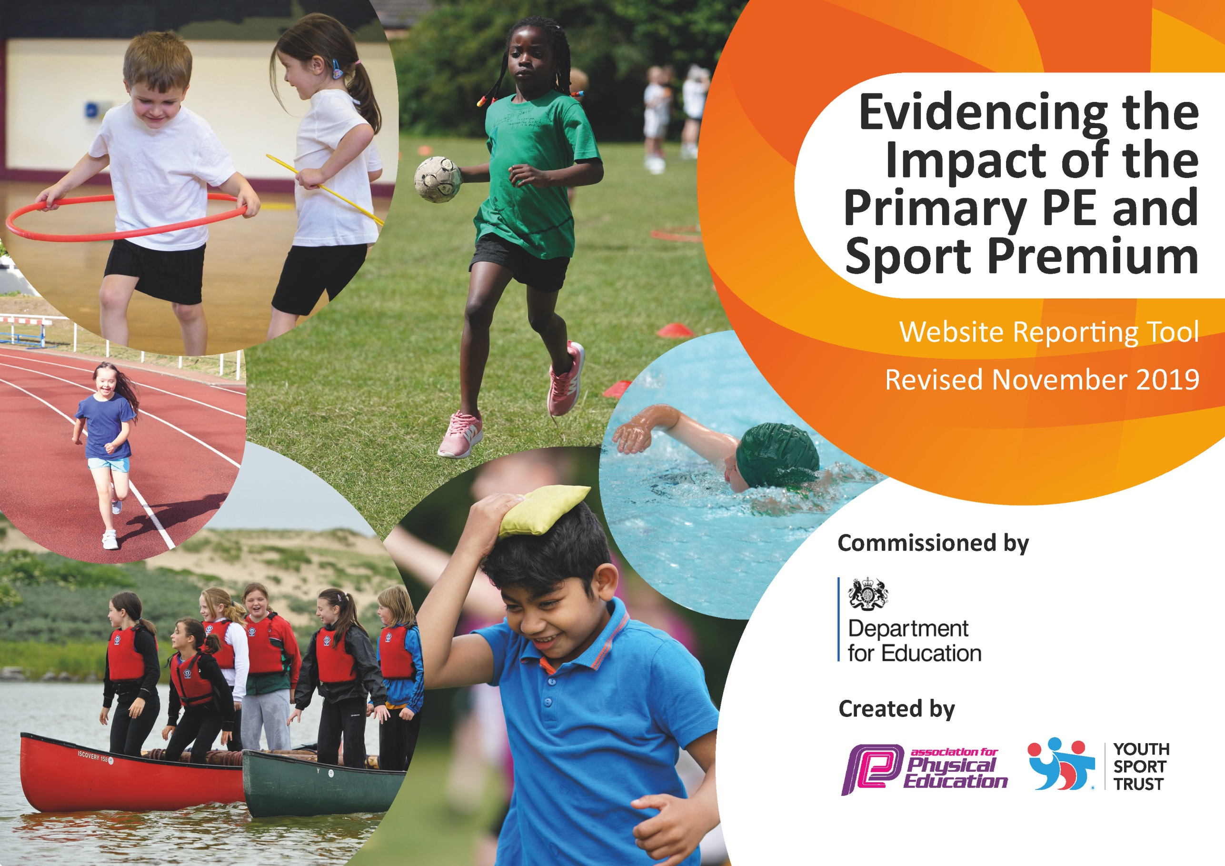
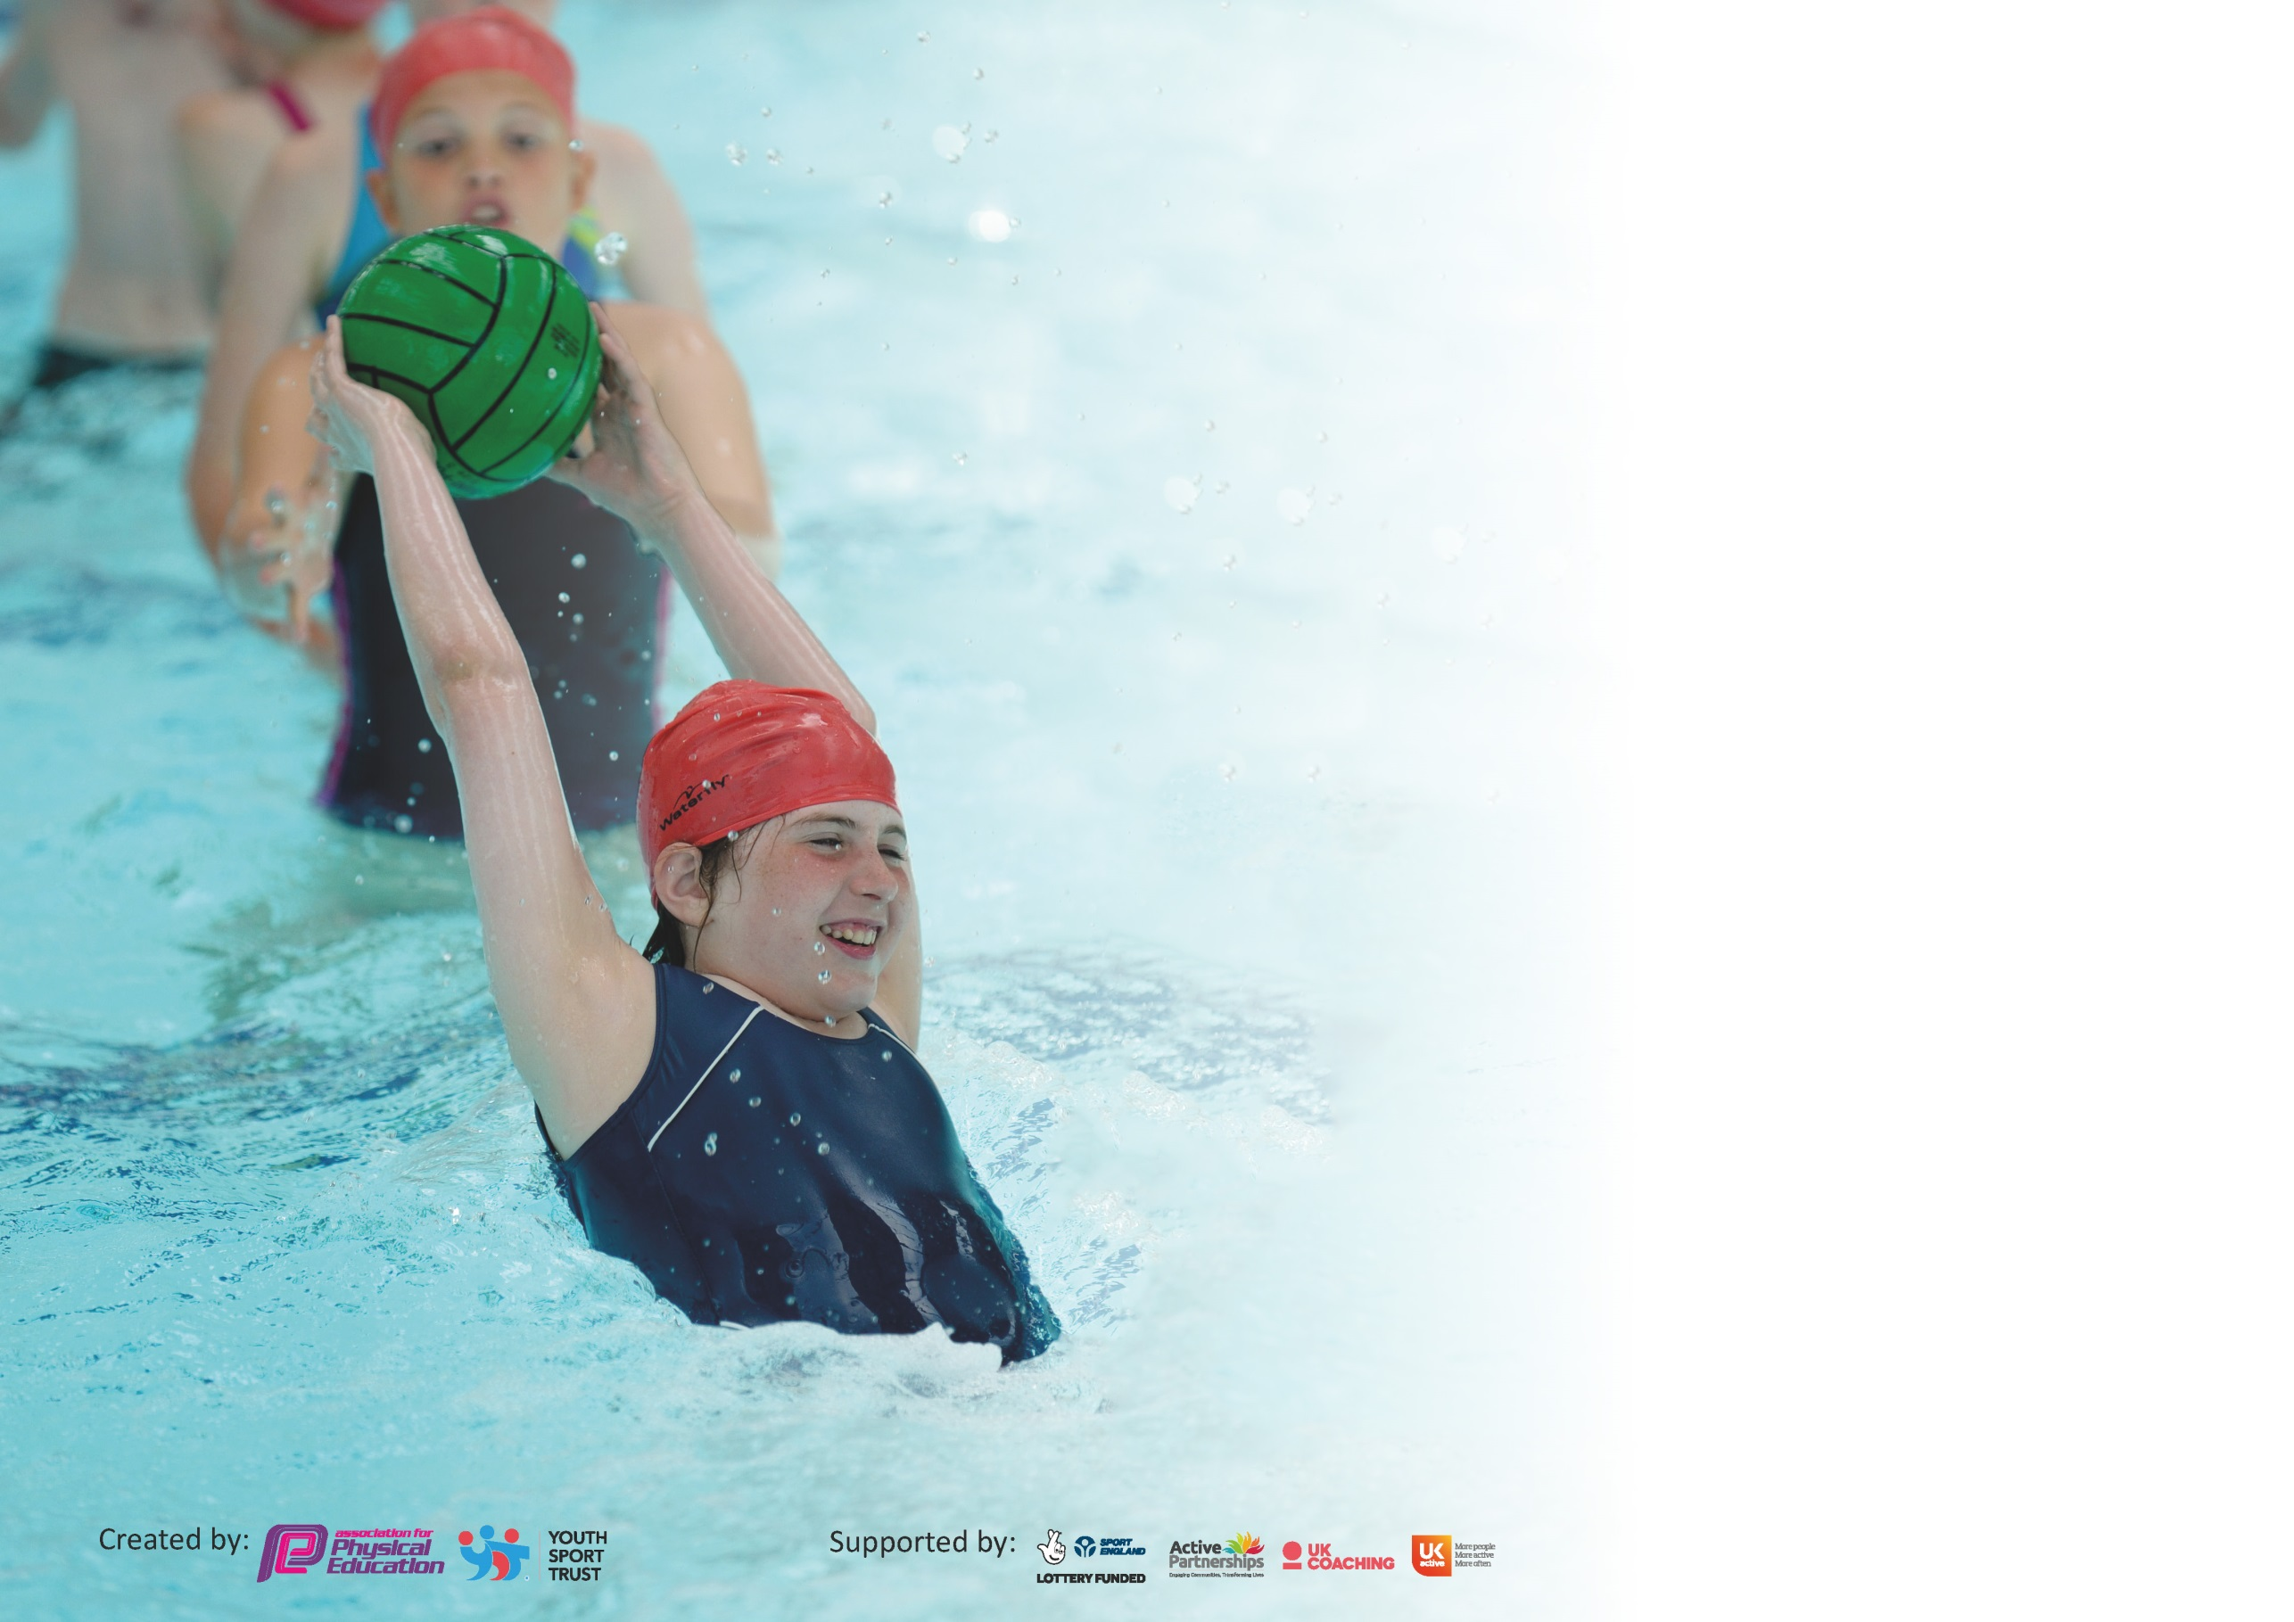

It is important that your grant is used effectively and based on school need. The Education Inspection Framework (Ofsted 2019 p64) makes clear there will be a focus on ‘whether leaders and those responsible for governors all understand their respective roles and perform these in a way that enhances the effectiveness of the school’.

Under the Quality of Education criteria (p41) inspectors consider the extent to which schools can articulate their curriculum (INTENT), construct their curriculum (IMPLEMENTATION) and demonstrate the outcomes which result (IMPACT).

To assist schools with common transferable language this template has been developed to utilise the same three headings which should make your plans easily transferable between working documents.

Schools must use the funding to make additional and sustainable improvements to the quality of Physical Education, School Sport and Physical Activity (PESSPA) they offer. This means that you should
use the Primary PE and Sport Premium to:

- Develop or add to the PESSPA activities that your school already offer
- Build capacity and capability within the school to ensure that improvements made now will benefit pupils joining the school in future years

Please visit gov.uk for the revised DfE guidance including the 5 key indicators across which schools should demonstrate an improvement. This document will help you to review your provision and to report your spend. DfE encourages schools to use this template as an effective way of meeting the reporting requirements of the Primary PE and Sport Premium.

We recommend you start by reflecting on the impact of current provision and reviewing the previous spend.

Schools are required to publish details of how they spend this funding as well as on the impact it has on pupils’ PE and sport participation and attainment by the end of the summer term or by 31st July 2020 at the latest.

We recommend regularly updating the table and publishing it on your website throughout the year. This evidences your ongoing self-evaluation of how you are using the funding to secure maximum, sustainable impact. Final copy must be posted on your website by the end of the academic year and no later than the 31st July 2020. To see an example of how to complete the table please click HERE.

Support for review and reflection - considering the 5 key indicators from DfE, what development needs are a priority for your setting and your pupils now and why? Use the space below to reflect on previous spend and key achievements and areas for development.

Key achievements to date until July 2019: | Areas for further improvement and baseline evidence of need:
- REAL PE top up training Day 1 completed.  - Positive playtimes-new playground markings with defined areas for each phase.  - Competition-Two term involvement in PSSP and Plymouth Argyle events.  - Play leaders employed.  - Website/Twitter/Facebook being used successfully to promote sporting success. | - Complete top up training (missed Day 2 due to COVID-19).  - SEND sporting opportunities to be developed.  - Train Year 6 sports leaders.  - Participation numbers to be monitored.  - Assessment (Fundamental Movement Skills) in PE to inform future learning opportunities.

Meeting national curriculum requirements for swimming and water safety.
What percentage of your current Year 6 cohort swim competently, confidently and proficiently over a distance of at least 25 metres?  N.B. Even though your pupils may swim in another year please report on their attainment on leaving  primary school at the end of the summer term 2020. | 65%
What percentage of your current Year 6 cohort use a range of strokes effectively [for example, front crawl, backstroke and breaststroke]? | 65%
What percentage of your current Year 6 cohort perform safe self-rescue in different water-based situations? | 65%
Schools can choose to use the Primary PE and Sport Premium to provide additional provision for swimming but this must be for activity over and above the national curriculum requirements. Have you used it in this way? | No, due to COVID-19.

Action Plan and Budget Tracking
Capture your intended annual spend against the 5 key indicators. Clarify the success criteria and evidence of impact that you intend to measure to evaluate for pupils today and for the future.

Academic Year: 2019/20 | Total fund allocated: £17,510 | Date Updated: July 2020
Key indicator 1: The engagement of all pupils in regular physical activity – Chief Medical Officer guidelines recommend that primary school pupils undertake at least 30 minutes of physical activity a day in school |  |  |  | Percentage of total allocation:
 |  |  |  | 38%
Intent | Implementation |  | Impact
Your school focus should be clear what you want the pupils to know and be able to do and about  what they need to learn and to  consolidate through practice: | Make sure your actions to achieve are linked to your intentions: | Funding allocated: | Evidence of impact: what do pupils now know and what can they now do? What has changed?: | Sustainability and suggested next steps:
- To engage pupils in positive physical activities at playtimes and lunchtimes. | - Lunchtime play leaders employed and trained to deliver activities.  - Online training for MTAs during lockdown. | £6634.00 | - Pupils engage more positively at playtimes and lunchtimes, increased participation and activity levels but a reduction in the number of accidents. | - PE subject leader to engage MTAs in training opportunities.  - Ensure completion of ‘positive play’ online training for all MTAs.
Key indicator 2: The profile of PESSPA being raised across the school as a tool for whole school improvement |  |  |  | Percentage of total allocation:
 |  |  |  | 4%
Intent | Implementation |  | Impact
Your school focus should be clear what you want the pupils to know and be able to do and about  what they need to learn and to  consolidate through practice: | Make sure your actions to achieve are linked to your intentions: | Funding allocated: | Evidence of impact: what do pupils now know and what can they now do? What has changed?: | Sustainability and suggested next steps:
- To raise the profile of developing early fundamental skills in nursery.  - To improve the teaching of dance across the school.  - To utilise local clubs to raise participation levels in after school clubs and competitions. | - Autumn Term multi skills sessions-weekly (15 pupils benefited from specialist teaching).  - Dance specialist from Stoke Damerel Community College taught a progressive unit of work over three terms (observed by class teacher to develop their own practice).  - Plymouth Argyle subscription purchased and after school events/competitions attended. | £700.00  Part of PSSP subscription.  £80.00 | - Improve development of fundamental movement skills. Positive engagement in early PE.  - Class teachers develop their own ability to teach dance, supported by the specialist dance teacher.  - Pupils in Year 4, 5 and 6 participated in dodgeball, mutli skills and football at the Manadon Hub (Term 1-4). | - EYFS investment-PE resources to be purchased in the new EYFS provision to promote physical activity.  - Purchase the Association for PE’s Safe Practice in PE, School Sport and Physical Activity.

Key indicator 3: Increased confidence, knowledge and skills of all staff in teaching PE and sport |  |  |  | Percentage of total allocation:
 |  |  |  | 4%
Intent | Implementation |  | Impact
Your school focus should be clear | Make sure your actions to | Funding | Evidence of impact: what do | Sustainability and suggested
what you want the pupils to know | achieve are linked to your | allocated: | pupils now know and what | next steps:
and be able to do and about | intentions: |  | can they now do? What has
what they need to learn and to |  |  | changed?:
consolidate through practice:
- All pupils receive daily exercise and at least 2 hours of high quality PE each week.  - Improve activity levels and develop fundamental movement skills through the delivery of quality PE lessons. | - REAL PE training for new staff (Day 1)  - Jasmine platform purchased.  - PE subject leader created and shared the whole school programme for PE and sport. | £740.00 | - Day 1 REAL PE top up training completed in Term 2.  - Attendance at the PE conference.  - REAL PE and Val Sabin resources support teacher competence and outcomes for pupils. | - Complete Day 2 REAL PE top up training (due to COVID-19)  - Pupil voice questionnaire completed by Key Stage 2 pupils asking about the current provision and sport in school.  - Monitoring of PE (drop ins) to support teaching and learning.
Key indicator 4: Broader experience of a range of sports and activities offered to all pupils |  |  |  | Percentage of total allocation:
 |  |  |  | 32%
Intent | Implementation |  | Impact
Your school focus should be clear | Make sure your actions to | Funding | Evidence of impact: what do | Sustainability and suggested
what you want the pupils to know | achieve are linked to your | allocated: | pupils now know and what | next steps:
and be able to do and about | intentions: |  | can they now do? What has
what they need to learn and to |  |  | changed?:
consolidate through practice:
- To purchase quality resources; pupils continue to receive quality provision in curriculum PE and extra-curricular sport.  - To improve the playground atmosphere so it promotes ‘being active’ at playtimes and lunchtimes. | - Resources purchased; playground ‘fit trail’ markings installed; giant pencils installed. | £5536.00 | - Limited impact due to COVID-19. However, Educare, Foundation and Year 1 pupils are making positive use of the new playground markings. | - Develop the SEND sporting provision (attend New Age Kurling and Boccia events).  - KS1 playtime provision.

Key indicator 5: Increased participation in competitive sport |  |  |  | Percentage of total allocation:
 |  |  |  | 22%
Intent | Implementation |  | Impact
Your school focus should be clear | Make sure your actions to | Funding | Evidence of impact: what do | Sustainability and suggested
what you want the pupils to know | achieve are linked to your | allocated: | pupils now know and what | next steps:
and be able to do and about | intentions: |  | can they now do? What has
what they need to learn and to |  |  | changed?:
consolidate through practice:
- To increase the number of pupils engaged in competitive sporting events, including SEND pupils. | - Key Stage 2 engaged in a range of PSSP, Plymouth Argyle and trust activities. | £3500.00 PSSP partnership.  £320.00 supply to release teachers to attend events.  Plymouth Argyle subscription. | - Football, netball, dodgeball, multi skills- (reduced this year due to COVID-19). | - Gain School Games Bronze in 20/21.  - Train new play leaders to lead intra-school mini events.

Signed off by
Head Teacher: | J. Roberts
Date: | 14/07/20
Subject Leader: | R. Jennings
Date: | 14/07/20
Governor: | J. Carr
Date: | 14/07/20

