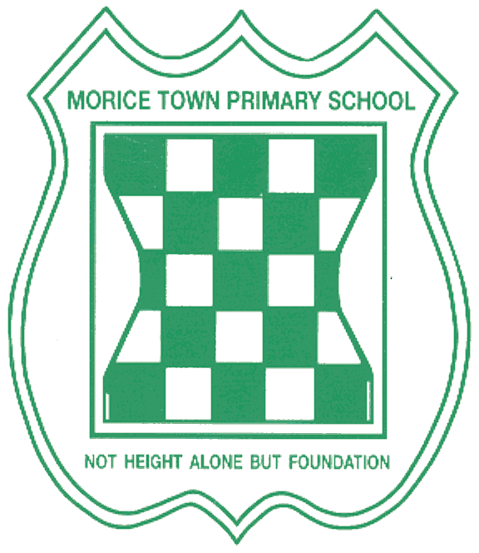

Drake Primary School and Morice Town Primary School
Governor Training Records 2017 onwards

June 17
- Understanding Safeguarding

September 2017
- Therapeutic play

November 2017
- Autism awareness diploma
- PIP’s

June 2018
- Youth Mental Health First Aid

September 2018
- Understanding Ofsted inspections
- Safeguarding
- Understanding Children and Young People’s Mental Health (Level 2)
- SEND level 2,3 and 4
- Prevent

November 2018
- Looked after children
- Safeguarding update

January 2019
- Reach South Yr2 SAT’s training

February 2019
- Plymouth City Council Yr2 SAT’s Training
- Preparing for Ofsted

April 2019
- Safer Recruitment in Education

May 2019
- Safeguarding training

September 2019
- Bribery and corruption
- Prevent training

October 2019
- Compliments, Concerns & Complaints
- Exclusions Appeals - the work of an independent review panel
- Exclusions - The Governor role
- Headteacher appraisal and well-being
- The role of the parent governor
- The role of the staff governor

Clerk training – 2018 onwards

- Safeguarding and Child protection Oct 19
- Preventing Radicalisation Oct 19
- Chairs and Clerks update - February 2019, June 2018, January 2018
- Compliment, Concerns and Complaints training - November 2018
- Clerking Competency framework 2017 - July 2018

