Owl

Owl
Was darker
Than ebony
Flew through the night
Eyes like amber searchlights,
Rested on a post,
Feathers wind-ruffled,
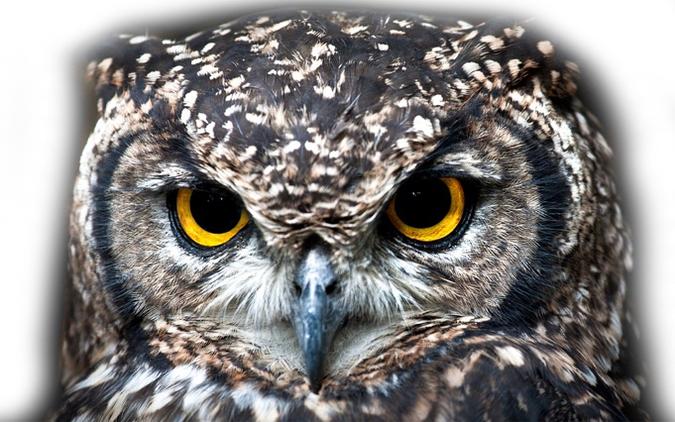
Stood stump still,
Talons ready to seize
And squeeze.

Owl
Was death
That swamped the fields,
For it flew through the dark
That tightened its knot,
That bandaged the hills
In a blindfold of fear.

Owl flew – who – who – who –

Pie Corbett

The Sparrow

I found a speckled sparrow
between the showers of rain.

He thought the window wasn’t there
and flew against the pane.

I picked him up and held him.
He didn’t stir at all.
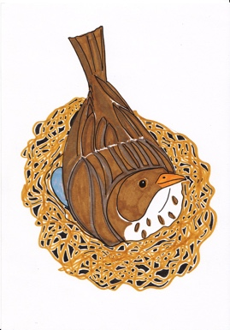
I hardly felt him in my hand,
he felt so soft and small.

I held him like a flower
upon my open palm.

I saw an eyelid quiver,
though he lay still and calm.

I never thought a bird so limp
could fly away so fast.

Questions about Owl

Find and copy a simile that is used in the poem (if you are not sure what a simile is, look back at the work you did on Day 2.)

_______________________________________________________________________

Alliteration is when several words in a row begin with the same sound (the big bad bird; a few fake flowers). Find and copy an example of alliteration in the poem.

_______________________________________________________________________

Is Owl an example of rhyming verse or free verse? If you are not sure what free verse is, ask a grown up if you can look it up in a dictionary on online.

_______________________________________________________________________

Suggest another word or words for:

flew ___________________________________________________________________

ruffled _________________________________________________________________

bandaged ______________________________________________________________

Describe how the poem makes you feel.

____________________________________________________________________________________________________________________________________________________________________________________________________________________________________________________________________________________________

Questions about The Sparrow

What has happened to the sparrow in the poem?
_______________________________________________________________________

The Sparrow is an example of rhyming verse.
Copy down two pairs of rhyming words from the poem.
________________________________ and ___________________________________
________________________________ and ___________________________________

‘and flew against the pane.’ A pane is a sheet of glass. Write down a homophone for the word pane (see Day 2 if you need to check what a homophone is). Write a sentence with your word in it.

_______________________________________________________________________

In your own words, explain how you think the sparrow in the poem is feeling.

____________________________________________________________________________________________________________________________________________________________________________________________________________________________________________________________________________________________

How is the mood of The Sparrow different to that of Owl?

Answers to questions
OWL
Find and copy a simile that is used in the poem
You could have:
- Darker than ebony
- Eyes like amber searchlights

Alliteration is when several words in a row begin with the same sound. Find and copy an example of alliteration in the poem.
You could have:
- Stood stump still
- Seize and squeeze
- …bandaged … blindfold

Is Owl an example of rhyming verse or free verse?
- It is an example of free verse. There is no regular rhyming pattern and nor is there a regular rhythm.

Suggest another word or words for:
flew fluttered / bumped / soared
ruffled disturbed / untidied / messed up
bandaged covered / bound / shielded / protected

The Sparrow
What has happened to the sparrow in the poem?
He flew against the window pane and knocked himself out.

The Sparrow is an example of rhyming verse. Copy down two pairs of rhyming words from the poem.
Rain / pane all / small calm / palm

‘and flew against the pane.’ A pane is a sheet of glass. Write down a homophone for the word pane. Write a sentence with your word in it.
Pain –
Example - The sparrow hit his head on the glass, and afterwards he was in pain all day with a headache.

