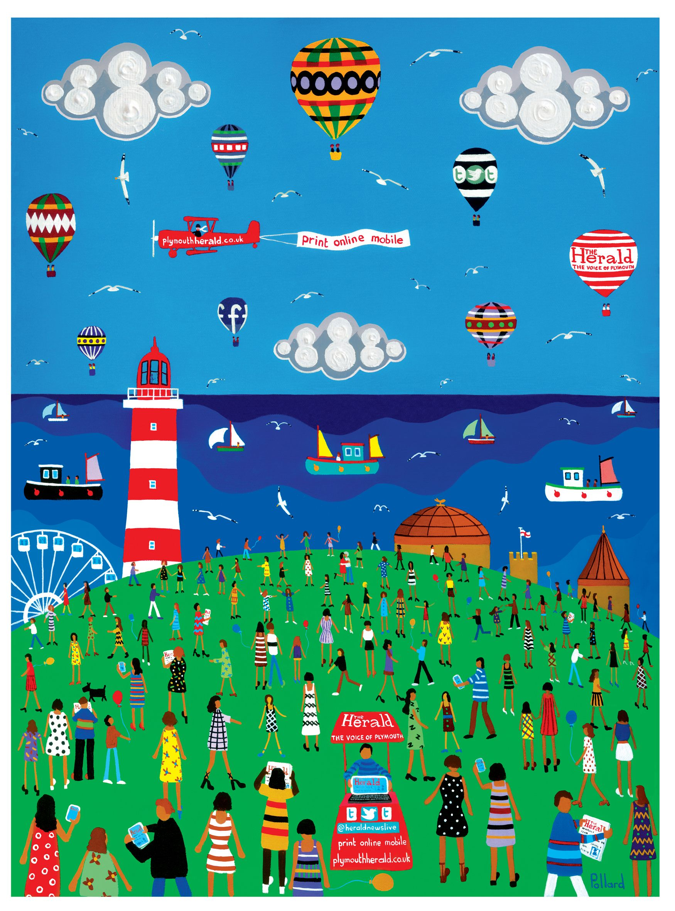

RE

In RE we will be learning about friendships and how to be a good friend to others.

Geography

This term we will be learning about our local area, looking at simple street maps and aerial photographs. We will also be looking at the different types of housing.

Theme

Our theme this term is Ship Ahoy! This will give the children the opportunity to explore water and pirate themed topics within school and on our school trip. They will learn about local history involving Sir Francis Drake and will consider seaside geography.

Art

This term we will be considering art that is local to Plymouth. Brian Pollard (local artist) will be visiting us.

Science

This term the children will be learning about plants and seasonal changes. This will link with our trip to the Aquarium.

PE We will complete REAL PE Units 5 and 6, which focuses on agility through ball chasing and also on improving balance skills.

Music

This term we will be looking at different ways instruments produce sound and to play un-tuned instruments rhythmically.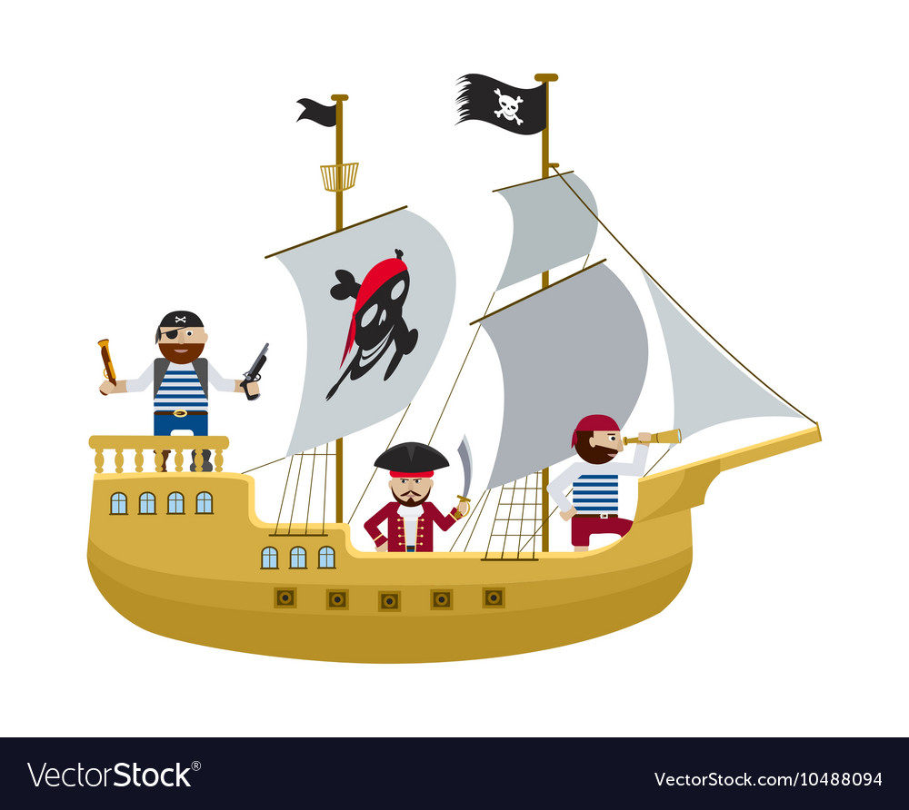

Year 1 Info:

Staff:

Mrs.Harrison – Class Teacher

Mrs.Webb – Full Time TA

Mr.Twynam – PPA Thursday afternoon.

PE Days: Tuesday and Wednesday

Diary dates:

Year 1 phonics screening; Week beginning 10th June.

Aquarium trip: 7th June

English

This term we will be learning how to write non-chronological reports and information texts. We will do this through our trip to the Aquarium and the Hoe.

Maths In maths, the children will be learning about time and money. We will also be introducing multiplication, division and simple fractions.

**WELCOME TO YEAR 1**