**Become an Artist – Tudor Portraits**

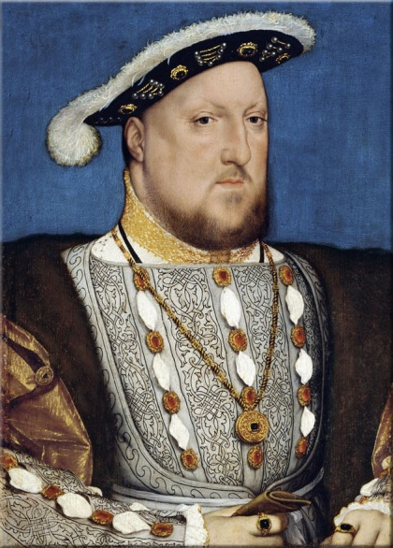 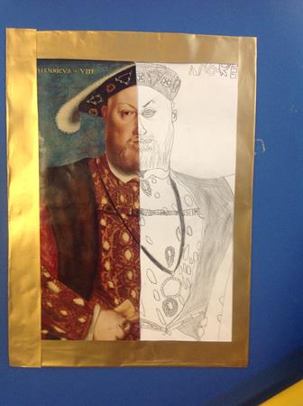

**Maths**

Continue practising your times tables using TTRockstars.

<https://play.ttrockstars.com/auth/school/student>

Become an artist from the Tudor Period and create your very own Henry VIII portrait. Start from scratch or complete one half of a portrait like the photo opposite.

Year 6

Spring Term

Home Learning Challenges

**Circuit Master**

Become the circuit master and use this website to create your own circuits.

<http://cleo.net.uk/resources/displayframe.php?src=207/consultants_resources%2Fscience%2FcircuitWorld%2Findex.html>

**Become a Writer!**

Write a short narrative based on a scene from Holes**.**

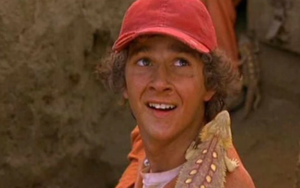

What is it like in a Victorian home? What did a Victorian classroom look like? Research either of these questions and create your very own Victorian room from a house or a classroom in a box!

**Be Creative!**

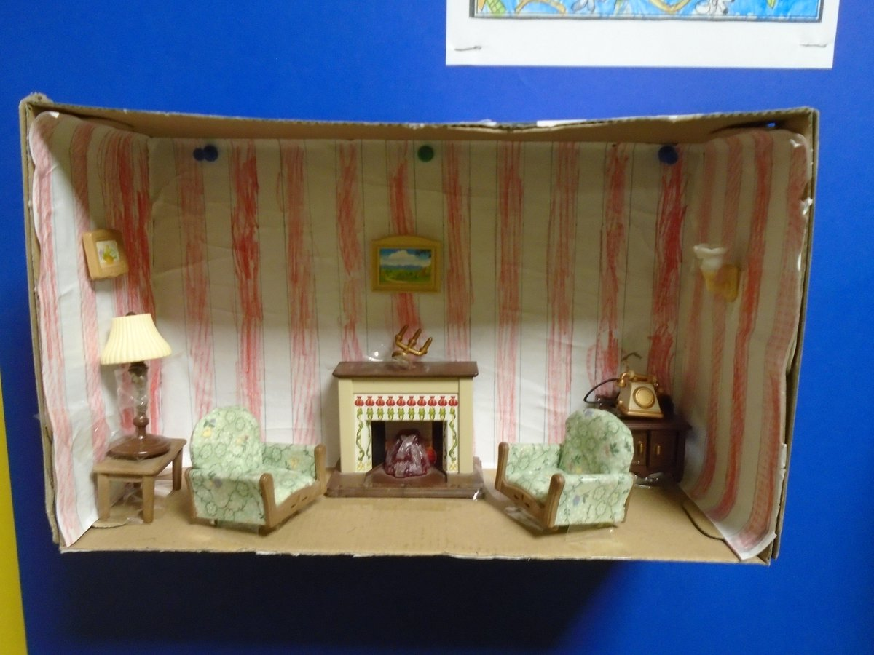

**Step Back in Time!**

Pick a period of British History that interests you. Research further and present your information in any interesting way you like.

Be creative and include: facts, dates and any visual diagrams or pictures.

**If you need any card, just ask!**