IALT hunt for 3D shapes.
Shape: | Tally: | Number:
sphere
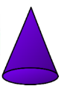
cone
cube
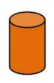
cylinder
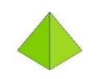
pyramid
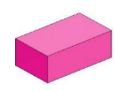
cuboid

