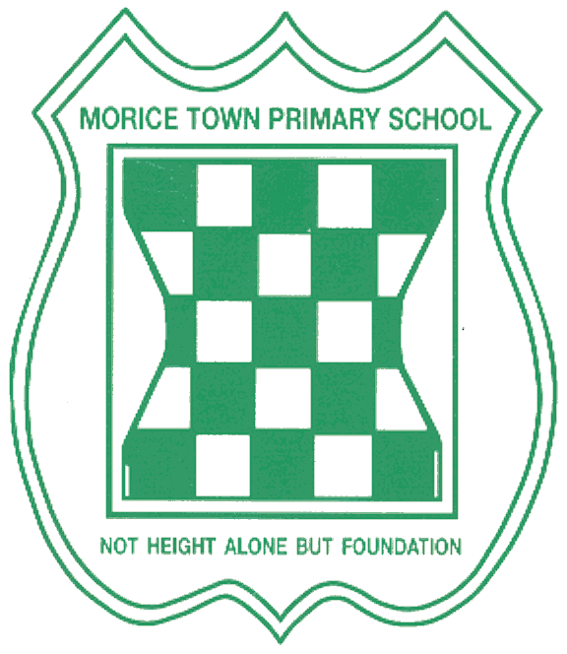

Drake and Morice Town Primary Academy’s Local Governing Body Meetings
2018-2019

Monday 11th February 2019
Monday 11th March 2019
Monday 13th May 2019
Monday 8th July 2019

All governors meeting start at 4pm.

