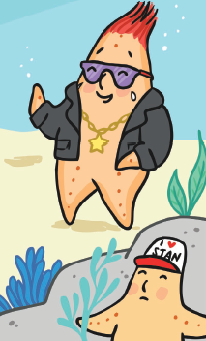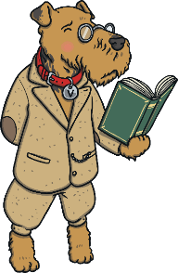**1.**

But Stan just laughed, “You’ll never learn, my talent is too **immense!**”

**Tick TWO words that means the same as immense.**

great small

terrible huge

**2. Match the words to the picture and meaning.**

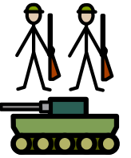

To stop attack.

yelp

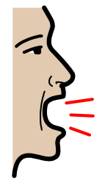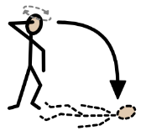

To cry out in

pain.

To faint from emotion.

To be too proud.

defence

boastful

swooned