Writing Activities 2

1. Story time
Go to https://www.youtube.com/watch?v=58kla7Ghxas .
Listen to Ruth reading Voices in the Park by Anthony Browne.
- Say what moods Charles’s Mum and Smudge’s Dad are in.
- Say why you think they are feeling like this.

2. The simple past tense
Read the information on The Past Tense 1: the Simple Past.
- Use what you have learned to complete the activity on Voices’ Verbs.
- Compare your work with the Answers. Correct anything you got wrong.

3. Another voice in the park
Read the instructions on Victoria’s Voice, Albert’s Voice.
- Write your dog’s recount out on Fifth Voice.
- Check that you used the simple past tense correctly in your sentences.

4. Look at details
- Look at In the Park.
List all the changes that happen from one side of the lamppost to the other. What other strange things can you see in the picture?

The Past Tense 1

All full sentences have an active verb in them.

The verb is the action or ‘doing’ word in the sentence.

I looked for Victoria. I ran towards the slide.
Smudge and Charles played on the seesaw.

All these verbs are in the simple form of the past tense. They describe a single action that has already happened – in the past, a while ago.

Stories are usually written in the past tense because they describe things (even imagined things) that happened in the past.

Some verbs are 'being’ or ‘feeling’ words.

Albert was happy. Smudge’s Dad felt sad.

Verbs can also be in the present tense.

I look for Victoria. I run towards the slide.
Smudge and Charles play on the seesaw

Here the action in each sentence happens right now, in the present moment.

Some past tense verbs have –ed on the end of their present tense form.

look/ looked play/ played

But many change more completely when going from the present to the past tense:

run/ran see/saw

are/were feel/felt

Voices Verbs

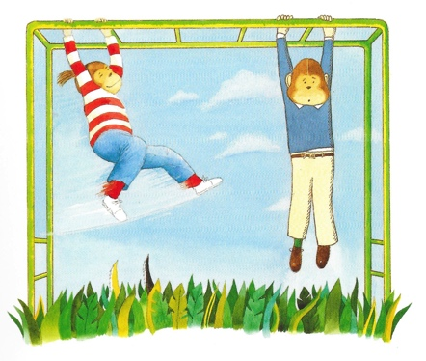

What to do:
1. Read the text.
2. Highlight the verbs in the simple past tense.
3. Six verbs have accidentally been left in the present tense. Whoops!
4. Find these. Rewrite each of them in the simple past tense on the lines below the text.

It was Tuesday, and Smudge and Charles return with the dogs to the park. Victoria and Albert dashed off and splash in the fountain once again, while the two children swing cheerfully on the monkey bars. They bought ice creams from the van at the park’s gates. The sky was blue, the sun shines and both Smudge and Charles felt happy together. They knew their parents loved them really, but it was still nice to have walked to the park with just the dogs. They laugh when Victoria chased a squirrel into the trees, and when Albert got his nose wraps up in an old crisp packet.

_____________________________ ______________________________

_____________________________ ______________________________

_____________________________ ______________________________

Voices Verbs

Answers

It was Tuesday, and Smudge and Charles return with the dogs to the park. Victoria and Albert dashed off and splash in the fountain once again, while the two children swing cheerfully on the monkey bars. They bought ice creams from the van at the park’s gates. The sky was blue, the sun shines and both Smudge and Charles felt happy together. They knew their parents loved them really, but it was still nice to have walked to the park with just the dogs. They laugh when Victoria chased a squirrel into the trees, and when Albert got his nose wraps up in an old crisp packet.

returned splashed
swung shone
laughed wrapped

Victoria’s Voice, Albert’s Voice

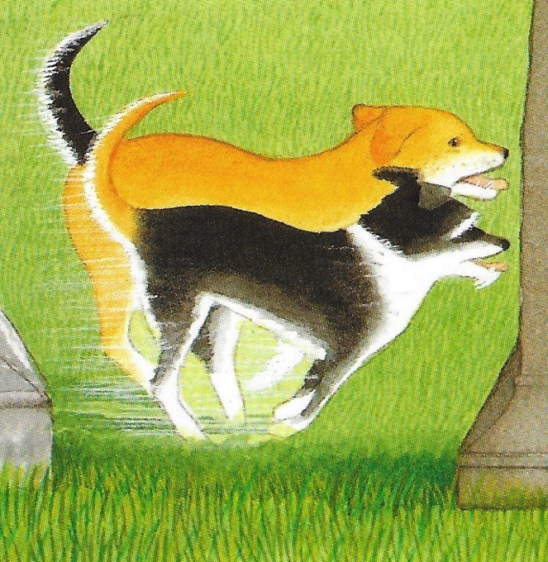

Imagine that you are either Victoria, Charles’s golden coloured dog, or Albert, Smudge’s black and white dog.

- Write either Victoria or Albert’s account of their day out.
- Give your dog their own ‘voice’ – describe the things that happened in the park (meeting a new dog, chasing through the trees and all over the park, swimming in the fountain, playing on the bandstand) from your point of view.
- Mention what you think of the dog you met and what you think of the other characters in the story.
- As you are writing a story, make sure your sentences are in the simple past tense.
- Draw or paint a picture in the style of Anthony Browne to go with your writing. Include some strange or unusual things in your picture!

Fifth Voice

In the Park
