Statutory Spellings Year 3 and 4

Your Challenge…
Please write the sentences in your neatest handwriting (exactly as they are written).Try to do this without using the Year 3 and 4 Statutory Spelling List sheet but if you do need it, that’s fine!
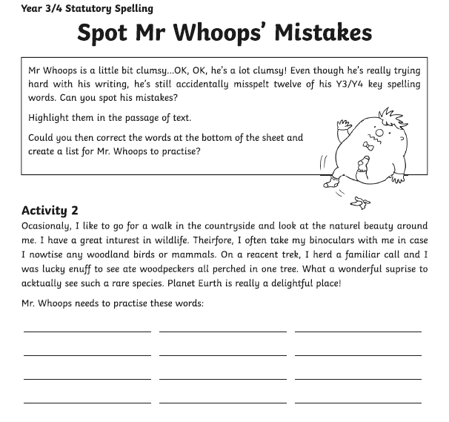

Remember…Please remember to use your neatest handwriting during this activity!

