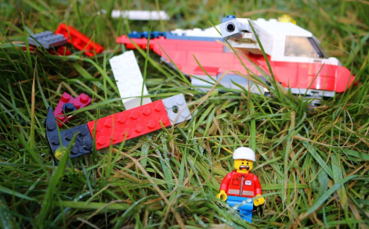

Lawrence was injured, afraid, lost and completely alone. He had been thrown viciously from the aircraft after the flock of birds had attacked the propellers.
As he laid there, listening to his racing heart, he wondered what would happen to him, when all of a sudden…

Please write the beginning of this story into your book in your neatest writing and then continue it. Your challenge is to fill one page of a4 - No more or no less! Good luck!

